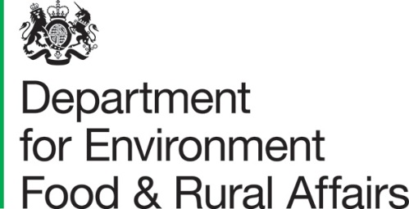 |  |  | T: 03459 335577  helpline@defra.gov.uk  www.gov.uk/defra
 |  |  | Date: 30 October 2023
Dear Consultee
Contractual relationships in the UK egg industry
We are writing to invite views on government proposals to extend the current mandatory poultry registration requirements to all bird keepers or to keepers of 10 or more birds at any single premises.

We are also seeking views on the proposal to require bird keepers to update their records on the register annually.

The following documents may be found on GOV.UK

- Consultation Document
- Privacy Notice

We welcome your views and comments on the options set out in the consultation.

Responses

To submit your consultation response please complete the consultation questionnaire provided through Citizen Space using the link provided (Citizen Space is an online consultation tool)

Responses should be received by 22 December 2023.

Confidentiality and data protection

Please find the Consultations Privacy Notice uploaded alongside this consultation.

This consultation document and consultation process have been planned to adhere to the Consultation Principles issued by the Cabinet Office.

This consultation document and the consultation process have been planned to adhere to the Consultation principles issued by the Cabinet Office.

Representative groups are asked to give a summary of the people and organisations they represent and where relevant who else they have consulted in reaching their conclusions when they respond.

Information provided in response to this consultation, including personal data, may be published or disclosed in accordance with the access to information regimes these are primarily the Environmental Information Regulations 2004 (EIRs), the Freedom of Information Act 2000 (FOIA) and the Data Protection Act 2018 (DPA). We have obligations, mainly under the EIRs, FOIA and DPA, to disclose information to recipients or to the public in certain circumstances. If you want the information that you provide to be treated as confidential, please be aware that, as a public authority, the Department is bound by the Freedom of Information Act and may therefore be obliged to disclose all or some of the information you provide. In view of this it would be helpful if you could explain to us why you regard the information you have provided as confidential. If we receive a request for disclosure of the information we will take full account of your explanation, but we cannot give an assurance that confidentiality can be maintained in all circumstances. An automatic confidentiality disclaimer generated by your IT system will not, of itself, be regarded as binding on the Department.

If you have any comments or complaints about the consultation process, please address them to the below address, or email

Consultation Coordinator, Defra

2nd Floor, Foss House, Kings Pool,

1-2 Peasholme Green, York, YO1 7PX
Or email: consultation.coordinator@defra.gov.uk

Thank you for your help in this matter. If you have any queries, please contact us. If you are unable to use Citizen Space, please contact us at:
eggcontractconsultation@defra.gov.uk

Yours sincerely

Supply Chain Fairness

