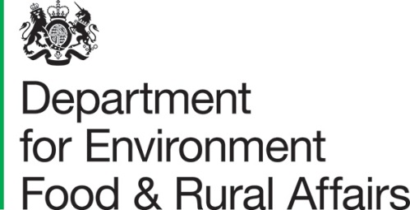 |  |  | T: 03459 335577  helpline@defra.gov.uk  www.gov.uk/defra
Ground Floor Seacole
2 Marsham Street
London
SW1P 4DF

 | Recipient name here  Recipient company  Address1  Address2  Address3  Postcode |  | Your ref: [goes here]  Our ref: [goes here]  Date: October 2022

Dear Consultee

Consultation on setting a compliance fee under the Waste Electronic and Electrical Equipment Regulations in 2023.
- I am writing to invite views on whether we should set a compliance fee for 2023. We also want your views on one proposal we received for managing this year’s fee.
- The use of a compliance fee and how it is administered is agreed annually. Companies that don’t meet their annual collection targets can comply with the 2013 WEEE Regulations by paying the compliance fee instead.

3. The following documents may be found on Defra’s website: [insert hyperlink: Citizen Space]
- Consultation document: “Consultation on setting a Waste Electronic and Electrical Equipment Regulations compliance fee for 2022.
- JTA Proposal
- FTI Consulting memorandum on WEEE compliance fee 2023
- Guidance on submitting a proposal for a compliance fee [July 2022]

4. We welcome your views and comments on the proposals. If you wish to obtain a copy of this consultation. Please contact weee@defra.gov.uk

Responses

5. To submit your consultation response please complete the consultation questionnaire provided through Citizen Space (Citizen Space is an on-line consultation tool).

6. Responses should be received by 13 November 2023

Consultation criteria

7. This consultation is in line with the Consultations Principles. This can be found at http://www.cabinetoffice.gov.uk/resource-library/consultation-principles-guidance

Confidentiality and data protection

This consultation document and consultation process have been planned to adhere to the Consultation Principles issued by the Cabinet Office.

Representative groups are asked to give a summary of the people and organisations they represent and where relevant who else they have consulted in reaching their conclusions when they respond.

Information provided in response to this consultation, including personal data, may be published or disclosed in accordance with the access to information regimes these are primarily the Environmental Information Regulations 2004 (EIRs), the Freedom of Information Act 2000 (FOIA) and the Data Protection Act 2018 (DPA). We have obligations, mainly under the EIRs, FOIA and DPA, to disclose information to particular recipients or to the public in certain circumstances.

If you want the information that you provide to be treated as confidential, please be aware that, as a public authority, the Department is bound by the Freedom of Information Act and may therefore be obliged to disclose all or some of the information you provide. In view of this it would be helpful if you could explain to us why you regard the information you have provided as confidential. If we receive a request for disclosure of the information we will take full account of your explanation, but we cannot give an assurance that confidentiality can be maintained in all circumstances. An automatic confidentiality disclaimer generated by your IT system will not, of itself, be regarded as binding on the Department.

This consultation is being conducted in line with the Cabinet Office “Consultation Principles” and be found at: https://www.gov.uk/government/publications/consultation-principles-guidance.

If you have any comments or complaints about the consultation process, please address them to:

Or email: consultation.coordinator@defra.gov.uk

Thank you for your help in this matter. If you have any queries, please contact us as above.

Yours Faithfully

Resources and Waste Division – Producer Responsibility and Product Regulation Tea,

weee@defra.gov.uk

Department for Environment, Food and Rural Affairs

