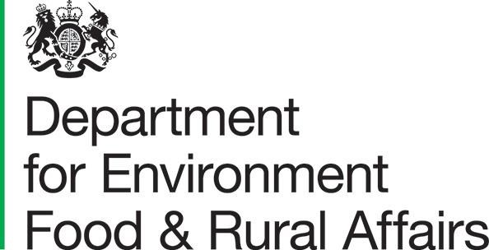
WEEE Compliance Fee Methodology 2022
Evaluation of Proposals
October 2022

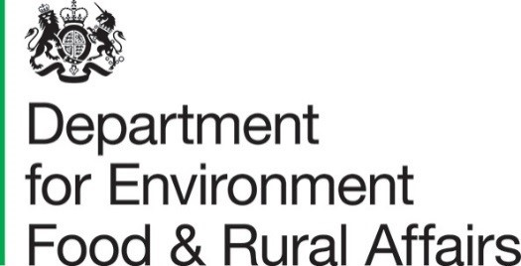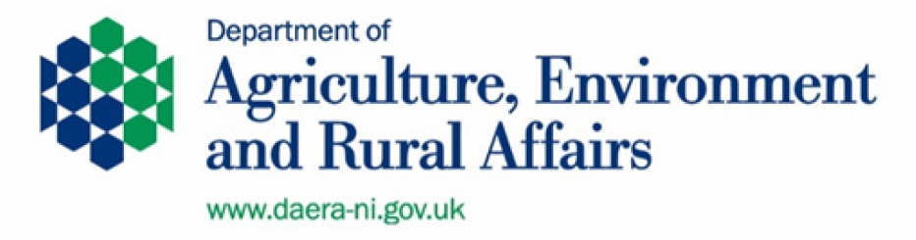

© Crown copyright 2021
You may re-use this information (excluding logos) free of charge in any format or medium, under the terms of the Open Government Licence v.3. To view this licence visit www.nationalarchives.gov.uk/doc/open-government-licence/version/3/ or email PSI@nationalarchives.gov.uk
This publication is available at www.gov.uk/government/publications
Any enquiries regarding this publication should be sent to us at
Department of Environment Food and Rural Affairs
Seacole Building
Ground floor
2 Marsham Street
London SW1P 4DF weee@defra.gov.uk www.gov.uk/defra

Contents
WEEE compliance fee methodology 2022 1
Evaluation of proposals 1
Audience 1
Duration 1
Confidentiality and data protection 1
Consultation principles 2
Help with enquiries 2
Tell us what you think 2
How to respond 2
Consultation questions 3
Next steps 4

WEEE compliance fee methodology 2022

Evaluation of proposals
The UK Waste Electrical and Electronic Equipment (WEEE) Regulations 2013 establish a system in which producers of equipment are required to finance the cost of collection, treatment, recovery and recycling of WEEE arising from private households. The WEEE Regulations establish a system of annual collection targets that are imposed on producer compliance schemes (PCSs). The Secretary of State has discretionary powers to approve a compliance fee methodology as an alternative form of compliance payable by PCSs that fail to achieve their collection target.
This consultation contains two proposals from external organisations for a compliance fee methodology and administrator for 2022. Comments are invited on whether the Secretary of State should set a compliance fee for 2022 and if so the extent to which each of the proposals meet the published evaluation criteria.

Audience
This consultation will be of interest to producers of electrical and electronic equipment, approved producer compliance schemes, WEEE treatment facilities, waste management companies, electrical re-use organisations and local authorities.

Duration
This consultation will close on Monday 14 November 2022.

Confidentiality and data protection
Information provided in response to this consultation, including personal information, may be subject to publication or release to other parties or to disclosure in accordance with the access to information regimes (these are primarily the Freedom of Information Act 2000 (FOIA), the Data Protection Act 1998 (DPA) and the Environmental Information
Regulations 2004 (EIR). If you want information, including personal data that you provide to be treated as confidential, please be aware that, under the FOIA, there is a statutory Code of Practice with which public authorities must comply and which deals, amongst other things, with obligations of confidence.
In view of this it would be helpful if you could explain to us why you regard the information you have provided as confidential. If we receive a request for disclosure of the information we will take full account of your explanation, but we cannot give an assurance that confidentiality can be maintained in all circumstances. An automatic confidentiality disclaimer generated by your IT system will not, of itself, be regarded as binding on the Department.

Consultation principles
The principles that Government departments and other public bodies should adopt for engaging stakeholders when developing policy and legislation are set out in the consultation principles. http://www.cabinetoffice.gov.uk/sites/default/files/resources/Consultation-Principles.pdf

Help with enquiries
Questions about the policy issues raised in the document should be addressed to:
Matthew Stocks
Resources and Waste Team
Department for Environment Food and Rural Affairs
Seacole Building
Ground floor
2 Marsham Street
London SW1P 4DF
Tel 020 8225 6700
Email: weee@defra.gov.uk

Tell us what you think

How to respond
To submit your consultation response, please use Citizen Space (our on-line consultation tool) at:
Our preferred method of consultation is online because it is the easiest way for us to collate and analyse responses. You can request a hard copy of our questionnaire (to complete and return by either email or post) by contacting us using the details above.

Consultation questions
We are interested in collecting the following information from those responding to the consultation:
- Your name and whether you are responding on behalf of an organisation
- Your address, email address and telephone number
- Whether you are a representative of a producer of electrical and/or electronic equipment, producer compliance scheme (PCS) , approved authorised treatment facility (AATF), waste management company, local authority, distributor (retailer or distance seller), electrical re-use organisation, or another type of organisation
You are not obliged to provide all the above information or respond to all the questions below.
In responding to the questions below it is important that you read the evaluation criteria that will be used by Defra for each of the proposals received for a WEEE Compliance Fee available at: https://www.gov.uk/government/publications/weee-submit-a-proposal-for-a-compliance-fee-methodologyfee-methodology

Question 1
Should the Secretary of State set a compliance fee for the 2022 compliance period (1 January – 31 December 2022)?
Please provide some comments and any supporting evidence you have available.

Question 2
Please score each of the two proposals received on how well they meet the published evaluation criteria as follows:
- – Unacceptable. Nil or inadequate proposal. Fails to demonstrate an ability to meet the requirement.
- – Poor. Proposal is partially relevant and poor. The response addresses some elements of the requirement but contains insufficient/limited detail or explanation to demonstrate how the requirement will be fulfilled.
- – Acceptable. Proposal is relevant and acceptable. The proposal demonstrates a broad understanding of the requirement but may lack details on how the requirement will be fulfilled.
- – Good. Proposal is relevant and good. The response demonstrates a good understanding of the requirement and provides sufficient details on how the requirement will be fulfilled.
- – Excellent. Proposal is relevant and excellent overall. The proposal is comprehensive, unambiguous and demonstrates a thorough understanding of the requirement and provides details of how the requirement will be met in full.
The scores above should then be multiplied by the weighting given in brackets against each of the criteria below. Example, if you believe the proposed methodology for calculation of the fee is “good” you will multiply 3 x 5 and enter a score of 15 in the table below.
Criteria | JTA Proposal | Valpak Proposal
Methodology for calculation of fee (5)
Administration of fee (3)
Methodology for dispersal of funds
(4)
Timetable for implementation of operation (3)
Experience of proposer and operator
(2)
Proposed IT systems (1)
TOTAL

Question 3
Please provide comments and any available evidence to support your scores against the published evaluation criteria.

Next steps
Any compliance fee methodology and compliance fee scheme operator approved by the
Secretary of State will be announced by mid-February 2023. This will allow sufficient time for PCSs to pay a compliance fee (should one be approved) and include evidence of payment with their Declaration of Compliance by the deadline of 31 March 2023.

