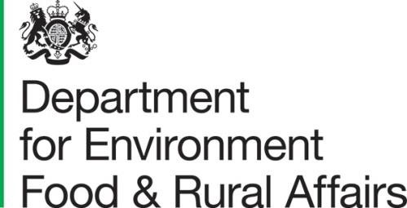
Seacole Building
2 Marsham Street
London SW1P 4DF
T: 03459 335577
helpline@defra.gov.uk
www.gov.uk/defra

19th March 2021

Dear Consultee,

CONSULTATION ON AN UPDATE TO THE NATIONAL IMPLEMENTATION PLAN FOR PERSISTENT ORGANIC POLLUTANTS

We would like to invite your views on what you think about our 2021 draft update to the UK National Implementation Plan (NIP) for the Stockholm Convention on Persistent Organic Pollutants (POPs). An update is required by the Convention periodically to explain how changes to the convention have been implemented, including when new POPs substances are listed for restriction, elimination or reduction or elimination of unintentional production.

The update covers “new POPs”, which have been more recently listed under the Stockholm Convention in 2017 and 2019 which were not covered in our last NIP update in 2017. It sets out the information available to us for these substances and our plans to monitor and eliminate them in the future. It also provides a short update on the older POPs and the actions taken since our last NIP update.

Defra and the Devolved Administrations want to consider the views of all stakeholders with an interest. Respondents can provide views on future plans and any additional information and evidence that supports our aim to eliminate or reduce the impact of POPs in the environment. This update has been drafted by Defra on behalf of the four governments of the UK and relevant arm’s length bodies. A formal consultation will enable due consideration of the range of views before a final revised NIP is published on the Stockholm Convention website later in 2021.

We welcome your views and comments on the update to the NIP. To submit your consultation response please complete the consultation questionnaire provided through Defra Citizen Space (an on-line consultation tool) at https://consult.defra.gov.uk/

If you wish to obtain a copy of this consultation please contact POPs@defra.gov.uk after which responses or additional information or documents can be sent to:

Consultation Coordinator
2nd floor Foss House
Kings Pool
1-2 Peasholme Green
York YO1 7PX

Consultation responses must be received by 14th May 2021.

This consultation document and consultation process have been planned to adhere to the Consultation Principles issued by the Cabinet Office which can be found at: www.gov.uk/government/publications/consultationprinciplesguidance.

Representative groups are asked to give a summary of the people and organisations they represent and where relevant, who else they have consulted in reaching their conclusions when they respond.

Information provided in response to this consultation, including personal data, may be published or disclosed in accordance with the access to information regimes. These are primarily the Environmental Information Regulations 2004 (EIRs), the Freedom of Information Act 2000 (FOIA) and the Data Protection Act 2018 (DPA). We have obligations, mainly under the EIRs, FOIA and DPA, to disclose information to particular recipients or to the public in certain circumstances.

If you want the information that you provide to be treated as confidential, please be aware that, as a public authority, the Department is bound by the Freedom of Information Act and may therefore be obliged to disclose all or some of the information you provide. In view of this it would be helpful if you could explain to us why you regard the information you have provided as confidential. If we receive a request for disclosure of the information we will take full account of your explanation, but we cannot give an assurance that confidentiality can be maintained in all circumstances. An automatic confidentiality disclaimer generated by your IT system will not, of itself, be regarded as binding on the Department.

If you have any comments or complaints about the consultation process, please address them to the Consultation Coordinator at the above postal address or email consultation.coordinator@defra.gov.uk

Thank you for your help in this matter.

Persistent Organic Pollutants Team
Department for Environment, Food and Rural Affairs

