Document Control

Title | Margate and Long Sands EMS Fisheries in MPA assessment
Author | E Young/N Greenwood/L Stockdale/M Kirby
Approver | M Coyle/L Stockdale
Owner | L Stockdale

Revision History
Date | Author | Version | Status | Reason | Approver(s)
15/10/2014 | C Jackson | 1.1 | Draft | Initial draft | E Young
12/06/2015 | E Young | 1.4 | Draft | Incorporation of NE comments on IDRBNR | L Stockdale
12/08/2015 | N Greenwood | 1.7 | Draft
17/08/2015 | L Stockdale/M Coyle | 1.8 | Draft |  | L Stockdale/M Coyle
30/09/2015 | E Young | 2.0 | Draft | Incorporation of NE comments | L Stockdale
10/11/2015 | E Young | 2.1 | Draft | Incorporation of NE clarification comments | L Stockdale
08/12/2015 | L Stockdale | 2.2 | Draft | QA
15/01/2016 | E Young | 2.4 | Draft | Incorporated IFCA comments | L Stockdale
April - May | M Kirby | V0.1 | Draft | Updating to new assessment format | N Greenwood/L Stockdale
May - June | L Stockdale | V0.2 | Draft | Drafting and QA
24/06/2016 | M Coyle | V0.3 | Final | MMO QA | M Coyle
12/07/2016 | M Kirby | V0.4 | Draft | Updated Table 2 and Table 7 to clarify sub-feature assessment
31/08/2016 | M Van Wyk | V0.5 | Draft | Inserted “Footprint” section, updated p-values, re-wrote assessment into new MPA template format, renumbered. | L Stockdale
12/10/2016 | L Stockdale | V0.6 | Final | MMO revision after NE comments | L Stockdale

This document has been distributed for information and comment to:

Title | Title | Date sent | Comments received
V1.8 Margate and Long Sands EMS - Interim advice request | Natural England | 21/08/2015 | 14/09/2015 - Mike Quigley, Ingrid Chudleigh, Mark Duffy and Lucy Abram
V1.8 Margate and Long Sands EMS - Interim advice request | Kent And Essex IFCA | 21/08/2015 | 18/09/2015 - Will Wright, Jane Heywood and Vicky Foster
Natural England clarification note | Natural England |  | 12/11/2015 - Ingrid Chudleigh
V2.3 | Kent and Essex IFCA | 12/01/2016 | 15/01/2016 - Will Wright, Jane Heywood and Vicky Foster
V0.3 | Natural England and Kent and Essex IFCA | 28/06/2016 | 22/07/2016 - Natural England: Ingrid Chudleigh, Mike Quigley, Mark Duffy and Lucy Abram
V0.5 | Kent and Essex IFCA, Will Wright | 02/09/2016

Margate and Long Sands Site of Community Importance (SCI) MMO Fisheries Assessment
1. Summary
Table 1 shows a summary of the outcomes of this assessment of the impact of fishing in this SCI.
Features | Matrix Gear Type | Part A Outcome | Part B  Outcome | In-combination Assessment
Subtidal coarse sediment  and  Subtidal mixed sediments  and  Subtidal sand | Beam trawl (whitefish) | LSE | Adverse effect | No adverse effect with proposed management
 | Beam trawl (shrimp)
 | Beam trawl (pulse/wing)
 | Heavy otter trawl
 | Multi-rig trawls
 | Light otter trawl
 | Pair trawl
 | Mussels, clams, oysters | No LSE | No adverse effect
 | Pump scoop (cockles, clams)
 | Suction (cockles)
 | Gill nets | No LSE | No adverse effect
 | Trammels
 | Entangling
 | Drift nets (demersal)
 | Pots/creels (crustacea/gastropods)

2. Introduction

Table 2: Details of Area
Name and legal Status of site(s): | Name of site(s) | Legal status
 | Margate and Long Sands | SCI

The boundary of Margate and Long Sands European marine Site (EMS) encloses a series of sandbanks, the largest of which is Long Sand which lies in a north east – south west orientation along the line of the tidal flows entering the Thames estuary from the North Sea, Margate Sand lies to the south west of Long Sand, orientated east-west approximately along the line of the predominant tidal flow in the southern part of the Thames estuary which comes from the English Channel (figure 1). The extent and position of Margate Sand has changed very little over time, however in common with most sandbanks, other banks within the site (including Long Sand) are dynamic and fairly mobile (Natural England, 2016).

The fauna of the sandbank crests is characteristic of species-poor, mobile sand environments and is dominated by polychaete worms and amphipods. In the troughs and slopes, a higher diversity of polychaetes, crustacea, molluscs and echinoderms is found, with mobile epifauna including crabs and brown shrimp, squid and commercially important fish species such as sole and herring. There is a significant amount of the reef-forming ross worm (Sabellaria spinulosa) at this site, which when formed as a reef qualifies as an Annex I habitat (biogenic reef), however, the available data indicate that the distribution of S. spinulosa is patchy and that aggregations form crusts rather than reefs.

This assessment covers the Margate and Long Sands sandbank feature throughout the site (between the 0–12 nautical miles (nm) limits). MMO will lead on the assessment with input from Kent and Essex Inshore Fisheries and Conservation Authority (IFCA). Any required management measures inside 0-6nm, will implemented by Kent and Essex IFCA.

Table 3: Qualifying features
Feature | Sub feature | Fisheries matrix sub feature | Conservation objectives/General management approach
1110 Sandbanks which are slightly covered by sea water at all times | Subtidal coarse sediment | Subtidal mixed sediments used as it is the most precautionary. | maintain or restore:  • the extent and distribution of qualifying natural habitats and habitats of the qualifying species  • the structure and function (including typical species) of qualifying natural habitats  • the structure and function of the habitats of qualifying species  • the supporting processes on which qualifying natural habitats and the habitats of qualifying species rely  • the populations of qualifying species  • the distribution of qualifying species within the site
 | Subtidal mixed sediments
 | Subtidal sand

Sandbanks which are slightly covered by sea water at all times

The Margate and Long Sands EMS sandbank feature extends out to the boundary of the site between the 0–12nm limit and is in depths of less than 25m below chart datum (BCD).

The fauna of the sandbanks is generally low diversity polychaete-amphipod communities which are typical of mobile sandy sediments. This is particularly true of the shallower sections of bank crests, although slightly higher diversity communities are found on the deeper sections of the banks. In the gravelly substrates in the troughs, more diverse communities of infauna and epifauna are present. Troughs between sandbanks, particularly the Queens Channel, support richer communities of echinoderms, crustacean and bivalve molluscs, as well as abundant infauna and aggregations of S. spinulosa. These aggregations do not appear to form distinct reef structures. The area is known to be a spawning and nursery ground for a number of species of fish, including sole and herring (Natural England, 2012).

Mobile sediment is a continually disturbed environment where the substrate is subjected to tidal or wave driven movement.

Crustaceans are also widespread across the site. The most common crustacean is the brown shrimp with the common hermit crab as the next most common species found. Other species widely recorded were crabs and pink shrimp (mainly outside 6nm). Echinoderm species are widespread across the Long Sands but with a relatively low diversity of species and abundance. Species include the common starfish, the green sea-urchin, and the brittlestars. Other species recorded are the encrusting bryozoans and hydroids living on the shells of hermit crab (RPS Group PLC, EMU LTD, 2006). The European common squid was also frequently recorded (Natural England, 2012).

Long Sands is a nursery ground for a wide variety of fish, such as sole, plaice, dab, herring, whiting, pout, pogge, horse mackerel, sprats, sea bass and a variety of rays. Fish of high importance as prey for other fish and birds include sprats and herrings, gobies (mainly sand gobies and transparent gobies), sand eels, and flatfish of various species (RPS Group PLC, 2005; EMU LTD, 2006). Margate Sands site is likely to be of particular importance as a spawning area for herring, and possibly for sandeel (BMT Cordah, 2003).

Feature extent
In order to factor in natural migration, at the time of designation of Margate and Long Sands EMS a “margin” was factored into the site boundary to allow natural migration of the sandbanks over a 10 year period (Appendix 1).
Due to the margin added to factor in this migration, the MMO has assessed the whole of site as sandbank feature.
Sub-feature: Subtidal coarse sediment
This habitat is located predominantly in the southern section of the site, running offshore parallel from Birchington-on-sea to Herne Bay and extending further offshore into the Thames estuary to a distance of approximately 15km. This subfeature also appears towards the northern end of the site, and is closely associated with subtidal mixed sediments. Sands and gravels typically provide an ideal habitat for many benthic marine species, as well as burrowing communities (Joint Nature Conservation Committee, 2014).

Sub-feature: Subtidal mixed sediments
This subfeature is less extensive within the Margate and Long Sands EMS and is only located at the north eastern tip of the site. This relatively small area of subtidal mixed sediment is surrounded predominantly by subtidal sand, but also abuts a small occurrence of subtidal coarse sediments. Consisting of mixed gravelly sands and muddy sands, this subfeature provides an ideal habitat for many benthic marine species including a range of bivalves and polychaete worms (Natural England, 2016, Bhatia, 2015).

Sub-feature: Subtidal sand
Subtidal sand is found throughout the site and forms the majority of the sediment type within Margate and Long Sands EMS. This subfeature is heavily influenced by the strong tidal currents within the site and as a result, parts of this subfeature are highly mobile. Typically this subfeature supports communities of lower diversity, particularly around the crests of the sandbanks (Natural England, 2016).

Site biotope map

In 2015 Natural England commissioned The Institute of Estuarine and Coastal Studies (IECS) (Bhatia 2015) to undertake a monitoring study of the site, in order to establish the benthic species composition and associated biotopes of the sandbank feature (annex 1). The result of this survey alongside Natural England advice on how to interpret the data has been used to inform the assessment of gear impact, on the sites qualifying feature and sub-features.

Site conditions
The sandbank feature is exposed to wave action and strong tidal flows, which includes disturbance by storms. This site is considered to be highly variable with highly mobile and more stable areas within the troughs, between the banks and areas towards the boundary of the site (furthest away from the banks (Long Sands Head) (Bhatia 2015)). Due to the natural dynamism of sandbanks and the potential oscillation of sandbanks by hydrodynamic processes tolerance and recoverability by species will vary (Kaiser et al 1998, Bolam et al 2014).

Figure 1: Margate and Long Sands EMS
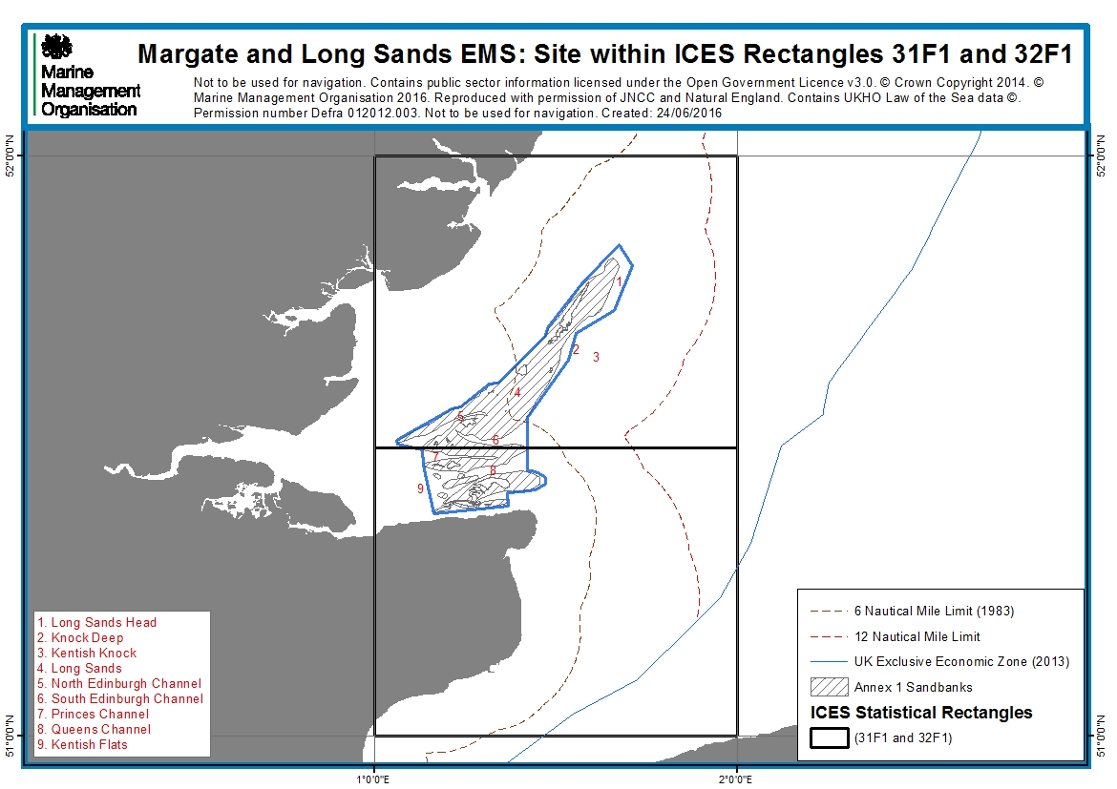

  - Scope of this assessment - fishing activities assessed
The geographic scope of this assessment covers the entire Margate and Long Sands EMS.
All fishing activity/feature interactions at this site identified as ‘amber’ in the Matrix of fisheries gear types and European marine site protected features (hereafter ‘the Matrix’) were considered for inclusion in this assessment. Fishing activity-feature interactions identified as ‘green’ are also assessed if there are in-combination effects with other activities.

Table 4 shows the fishing activities with amber interactions assessed at this site. The ‘matrix gear type’ column shows the categories used in the Matrix. These are matched to the ‘aggregated method’ categories used in Natural England conservation advice packages.

Table 4: Fishing activities with amber interactions included for assessment
Features | Matrix Gear Type | Natural England Aggregated Method
Subtidal coarse sediment  And  Subtidal mixed sediments  And  Subtidal sand | Anchor seine | Demersal seine
 | Scottish/fly seine
 | Beam trawl (whitefish) | Demersal trawl
 | Beam trawl (shrimp)
 | Beam trawl (pulse/wing)
 | Heavy otter trawl
 | Multi-rig trawls
 | Light otter trawl
 | Pair trawl
 | Scallops | Dredges
 | Mussels, clams, oysters
 | Pump scoop (cockles, clams)
 | Suction (cockles) | Hydraulic dredges
 | Pots/creels (crustacea/gastropods) | Traps
 | Cuttle pots
 | Fish traps
 | Gill nets | Anchored nets/lines
 | Trammels
 | Entangling
 | Drift nets (demersal)
 | Beach seines/ring nets | Shore-based activities
 | Shrimp push-nets
 | Fyke and stakenets
 | Bait dragging

Commercial sea fishing has the potential to vary in nature and intensity over time. This assessment considers a particular range of recent and likely future activity based on activity levels and type as identified in section 4.1.4.

To ensure that the conservation objectives of the site are not hindered should future activity occur outside of this range, the MMO will monitor activity at this site, and will review this assessment should certain conditions be triggered. See section 6 and 7 for more information on ongoing monitoring and control at this site.

- Part A Assessment
Table 5: Advice packages used for assessment
Feature | Package | Link
Sandbanks which are slightly covered by sea water at all times | SCI: Margate and Long Sands | https://www.gov.uk/government/publications/marine-conservation-advice-for-site-of-community-importance-margate-and-long-sands-uk0030371

Part A of this assessment was carried out in a manner that is consistent with the likely significant effect test required by article 6(3) of the Habitats Directive.
For each fishing activity, a series of questions were asked:
- Does the activity take place, or is it likely to take place in the future?
- What are the potential pressures exerted by the activity on the feature?
- Are the effects/impacts of the pressures likely to be significant?

For each activity assessed in Part A, there were two possible outcomes for each identified pressure-feature interaction:
- The pressure-feature interactions were not included for assessment in Part B if:
  - the feature is not exposed to the pressure, and is not likely to be in the future; or
  - the effect/impact of the pressure is not likely to be significant.

- The pressure-feature interactions were included for assessment in Part B if:
  - the feature is exposed to the pressure, or is likely to be in the future; and
  - the potential scale or magnitude of any effect is likely to be significant; or
  - it is not possible to determine whether the magnitude of any effect is likely to be significant.

Activities not taking place

Table 6 shows activities which are excluded from further assessment as they do not take place and are not likely to take place in the future.
Table 6: Activities not taking place in site and not likely to take place in the future
Interaction |  |  | Justification
Feature | Gear type | Sub type
Sandbanks which are slightly covered by sea water at all times | Towed (demersal) | Anchor seine | Activity does not occur at the site*
 |  | Scottish/fly seine
 | Dredges (towed) | Scallops
 | Static - pots/traps | Cuttle pots
 |  | Fish traps
 | Seine nets and other | Beach seines/ring nets
 |  | Shrimp push-nets
 |  | Fyke and stake nets
 | Miscellaneous | Bait dragging

*Activities either intertidal/inshore, beach seines/ring nets, shrimp push-nets, fyke and stake nets, expert opinion has informed the MMO that activities do not take place.

  - Potential pressures exerted by the activities on the feature
For the remaining activities, potential pressures were identified using Natural England’s draft conservation advice package identified in table 5 and associated advice on operations tables. All pressures identified other than those categorised as ‘not relevant’ were included (table 7).
Table 7: Potential pressures on the feature
Feature | Aggregated method | Potential pressures
Subtidal coarse sediment  and  Subtidal mixed sediments  and  Subtidal sand | - Anchored nets/lines  - Demersal trawl  - Dredges  - Hydraulic dredges  - Traps | Abrasion/disturbance of the substrate on the surface of the seabed
 |  | Introduction of other substances (solid, liquid or gas)
 |  | Introduction or spread of non-indigenous species
 |  | Litter
 |  | Penetration and/or disturbance of the substrate below the surface of the seabed, including abrasion
 |  | Removal of non-target species
 | - Anchored nets/lines  - Demersal trawl  - Dredges  - Traps | Organic enrichment
 | - Demersal trawl  - Dredges  - Hydraulic dredges | Changes in suspended solids (water clarity)
 |  | Physical change (to another seabed type)
 |  | Siltation rate changes (High), including smothering (depth of vertical sediment overburden)
 |  | Siltation rate changes (Low), including smothering (depth of vertical sediment overburden)
 | - Dredges  - Hydraulic dredges | Introduction of microbial pathogens

  - Significance of effects/impacts

To determine whether each potential effect or impact is likely to be significant, the sensitivity assessments and risk profiling of pressures from Natural England’s Advice on Operations were used (table 8). Tables have been combined for sub features where they can to save on repetition.

Table 8: Summary of pressures from specific activities on Subtidal coarse sediment, Subtidal mixed sediments and subtidal sand taken to Part B

Potential pressures | Anchored nets/lines |  |  | Demersal trawl |  |  |  |  |  |  | Dredges |  | Hydraulic dredges |  | Traps
 | Gill nets | Trammels | Entangling | Beam trawl (whitefish) | Beam trawl (shrimp) | Beam trawl (pulse/wing) | Heavy otter trawl | Multi-rig trawls | Light otter trawl | Pair trawl | Mussels, clams, oysters | Pump scoop (cockles, clams) | Suction (cockles) |  | Pots/creels (crustacea/gastropods)
Abrasion/disturbance of the substrate on the surface of the seabed | LSE – abrasion may result from anchors or footlines |  |  | LSE – abrasion from gear contacting the seabed |  |  |  |  |  |  |  |  | LSE – abrasion form water injection |  | LSE - from pots, lines and weights/anchors
Introduction or spread of non-indigenous species | No LSE – Ballast water is the main vector for the transmission of non-indigenous species. Fishing vessels less than 45m must have permanent ballast and thus this vector is not available
Litter | No LSE – Although fishing gear may be lost at this site which could potentially cause abrasion and removal of target and non-target species, due to the strong tidal currents and oceanic swells at the site it is unlikely to persist at the site for long enough to cause a significant impact
Penetration and/or disturbance of the substrate below the surface of the seabed, including abrasion | No LSE – Only the anchors will penetrate the seabed and this will be minor and localised |  |  | LSE - Gears are designed to interact with the seabed |  |  |  |  |  |  |  |  |  | No LSE - Only the anchors will penetrate the seabed and this will be minor and localised
Removal of non-target species | LSE – nets may catch crustacea or entangle and remove branching epifauna identified as key species at this site |  |  | LSE – gears are non-selective |  |  |  |  |  |  |  |  |  | LSE – Pots may remove
Organic enrichment | No LSE – Margate and Long Sands is subject to strong tides and currents and nutrients will be moved out of the area quickly
Changes in suspended solids (water clarity) | No LSE – interaction with the seabed is minor and will create localised changes in sediment which will disperse quickly |  |  | LSE - This pressure may result from physical disturbance of the sediment, along with hydrodynamic action caused by the passage of towed gear, leading to entrainment and suspension of the substrate behind and around the gear components |  |  |  |  |  |  |  |  |  | No LSE – interaction with the seabed is minor and will create localised changes in sediment which will disperse quickly
Physical change (to another seabed type) | No LSE – Only the anchors will penetrate the seabed and this will be minor and localised |  |  | No LSE – These gears are used on sandbank which will remain as sandy substrates after fishing has occurred |  |  |  |  |  |  |  |  |  | No LSE – Only the anchors will penetrate the seabed and this will be minor and localised
Siltation rate changes (Low), including smothering (depth of vertical sediment overburden) | No LSE – interaction with the seabed is minor and will create localised changes in sediment which will disperse quickly |  |  | LSE - This pressure may result from physical disturbance of the sediment, along with hydrodynamic action caused by the passage of towed gear, leading to entrainment and suspension of the substrate |  |  |  |  |  |  |  |  |  | No LSE – interaction with the seabed is minor and will create localised changes in sediment which will disperse quickly
Introduction of microbial pathogens | No LSE

- Part B Assessment
Part B of this assessment was carried out in a manner that is consistent with the appropriate assessment required by article 6(3) of the Habitats Directive.
Table 9 shows the fishing activities and pressures included for assessment in Part B. Pressures with similar potential impacts to a particular feature were grouped to save repetition during this assessment.
Table 9: Fishing activities and pressures included for Part B
Aggregated Method | Fishing Gear Type | Pressures
Anchored nets/lines | Gill nets | - Abrasion/disturbance of the substrate on the surface of the seabed  - Removal of non target species
 | Trammels
 | Entangling
 | Drift nets (demersal)
Demersal trawl | Beam trawl (whitefish) | - Penetration and/or disturbance of the substrate below the surface of the seabed, including abrasion  - Removal of non target species  - Changes in suspended solids (water clarity)  - Siltation rate changes (low), including smothering (depth of vertical sediment overburden)
 | Beam Trawl (shrimp)
 | Beam trawl (pulse/wing)
 | Heavy otter trawl
 | Light otter trawl
 | Multi-rig trawls
 | Pair trawl
Dredges | Mussels, clams, oysters | - Penetration and/or disturbance of the substrate below the surface of the seabed, including abrasion  - Removal of non target species  - Changes in suspended solids (water clarity)  - Siltation rate changes (low), including smothering (depth of vertical sediment overburden)
Hydraulic dredges | Suction (cockles) | - Penetration and/or disturbance of the substrate below the surface of the seabed, including abrasion  - Removal of non target species  - Changes in suspended solids (water clarity)  - Siltation rate changes (low), including smothering (depth of vertical sediment overburden)
Traps | Pots/creels (crustacea/gastropods) | - Abrasion/disturbance of the substrate on the surface of the seabed  - Removal of non target species

The Important targets for favourable condition were identified within Natural England conservation advice supplementary advice tables. ‘Important’ in this context means only those targets relating to attributes that will most efficiently and directly help to define condition.

Table 10 shows which targets were identified as important. The impacts of pressures on features were assessed against these targets to determine whether the activities causing the pressures are compatible with the site’s conservation objectives.

Table 10: Important favourable condition targets for identified pressures
Attribute | Target | Importance/justification
Distribution: presence and spatial distribution of subtidal sandbank communities | Maintain the presence and spatial distribution of subtidal sandbank communities. | Important for all pressures identified.
Extent and distribution of subtidal sandbanks | Maintain the total extent and distribution of subtidal sandbanks to ensure no loss of integrity, while allowing for natural change and succession. | Pressures do not affect extent and distribution of subtidal sandbanks.
Supporting processes: energy / exposure | Maintain the natural physical energy resulting from waves, tides and other water flows, so that the exposure [High / Medium / Low] does not cause alteration to the biotopes, and stability, across the habitat | Pressures do not alter subtidal sandbank energy or exposure.
Structure: presence and abundance of typical species | [Maintain OR Recover OR Restore] the abundance of listed typical species, to enable each of them to be a viable component of the habitat. | Key species not identified therefore cannot be assessed.
Structure: non-native species and pathogens | Restrict the introduction and spread of non-native species and pathogens, and their impacts. | Excluded in Part A assessment.
Supporting processes: sediment contaminants | Restrict surface sediment contaminant levels to concentrations where they are not adversely impacting the infauna of the feature and its subfeatures. | Pressures do not alter sediment contaminants.
Structure: volume | Maintain the existing (where no previous evidence exists) or best-known (where some evidence exists) volume of sediment in the sandbank, allowing for natural change. | Important for all pressures identified.
Structure: topography | Maintain the presence of topographic features, while allowing for natural responses to hydrodynamic regime, by preventing erosion or deposition through human-induced activity. | Important for all pressures identified.
Structure: species composition of component communities | Maintain the species composition of component communities of subtidal sandbanks. | Important for all pressures identified.
Supporting processes: energy / exposure | Maintain the natural physical energy resulting from waves, tides and other water flows, so that the exposure [High / Medium] does not cause alteration to the biotopes, and stability, across the habitat. | Pressures cannot change energy/exposure.
Supporting processes: physico-chemical properties | Maintain the natural physico-chemical properties of the water. | Pressures do not affect physic-chemical properties.
Supporting processes: sediment movement and hydrodynamic regime | Maintain all hydrodynamic and physical conditions such that natural water flow and sediment movement are not significantly altered or prevented from responding to changes in environmental conditions. | Important. Abrasion/ penetration/ disturbance of the surface of the seabed may affect sedimentation rate.
Supporting processes: water quality - contaminants | Restrict aqueous contaminants to levels equating to (High / Good) Status (according to Annex VIII and X of the Water Framework Directive), avoiding deterioration from existing levels | Pressures do not affect water quality.
Supporting processes: water quality - dissolved oxygen | Maintain the dissolved oxygen (DO) concentration at levels equating to High Ecological Status (specifically ≥ 5.7 mg per litre (at 35 salinity) for 95 % of the year), avoiding deterioration from existing levels. | Pressures do not affect water quality.
Supporting processes: water quality - nutrients | Maintain water quality, specifically mean winter dissolved inorganic nitrogen (DIN) at a concentration equating to High Ecological Status (mean winter DIN is < 12 µM for coastal waters), avoiding deterioration from existing levels. | Pressures do not affect water quality.
Supporting processes: water quality - turbidity | Maintain natural levels of turbidity across the habitat. | Not relevant. Pressures do not affect water quality.

4.1 Activity description: Anchored nets/lines, demersal trawl, dredges, hydraulic dredges and traps

4.1.1 Fisheries access/existing management

UK vessels operate throughout this site. French and Belgium vessels have access between the 6 – 12nm limits, with Belgium (targeting demersal fish) being the most active other Member State (OMS) within the site.
No management measures were required as part of the revised approach to Marine Protected Area (MPA) management in 2013/14 however, there are measures in place which cover the Margate and Long Sands EMS, detailed below:

- From 0 – 6nm: Kent and Essex IFCA byelaws

- Kent and Essex IFCA vessel size and engine power byelaw prohibits fishing from vessels over 17m in length and restricts engine power to a max of 221 kW (or for derated engines; 243 kW before derating) for vessels using towed fishing gear.

- Kent and Essex IFCA currently regulates the cockle fishing within its district (the southern part of the EMS), using the Thames Estuary Cockle Fishery Order 1994 and the KEIFCA Cockle Fishery Flexible Permit Byelaw. Both these fisheries have an annual Appropriate Assessment undertaken as part of the fisheries management process and as such we would refer you to these documents when regarding the impact of cockle dredging on the Margate and Long Sands EMS site.

- Kent and Essex IFCA whelk permit byelaw restricts fishers to a pot limit of either 10 or 300 pots and requires permit holders to provide data on the intensity of whelk potting.

- Kent and Essex IFCA parlour pots – crabs and lobsters byelaw, which states parlour pots must be fitted with at least one unobstructed escape gap.

- Kent and Essex IFCA marking pots and traps byelaw states that traps shall be clearly marked at all times with the letters and numbers of the vessel to which they belong or the owners name and address.

- Kent and Essex IFCA berried lobster byelaw, no person shall remove from a fishery any berried lobster.

- Kent & Essex IFCA placing and use of fixed engines byelaw restricts net length, stating that 'no net or fleet of nets shall exceed 1000m in length', with vessels able to shoot up to 5000m of nets in separate locations.
- From 6 – 12nm:

- The MMO and Cefas manage the Thames Estuary and Blackwater Herring fishery, setting herring quota and minimum mesh size (54mm).

4.1.2 Evidence Sources

To determine the levels of fishing activity, the following data sources were used:
- Vessel monitoring system (VMS)
- Fisheries landings data
- Fishermap
- Inshore fisheries sightings activity data
- National Federation of Fishermen’s Organisations (NFFO) project: Supporting risk-based fisheries assessments for MPAs - Assessment of Otter Trawling Activity in Margate and Long Sands Site of Community Importance (SCI) (2015)*
- Expert opinion
- Spatial footprint analysis using p-values

For more information about the data sources, please see appendix 2: MMO methodology. Data sources specifically used for this assessment and not across all MMO MPA assessments (*above) are detailed in Section 8.

Confidence in the data sources used is detailed in table 11; this confidence is further quantified within Section 8.

Table 11: Summary of generic confidence associated with fishing activity evidence

Evidence source | Confidence | Description, strengths and limitation
VMS data | High / Moderate | - Confidence in VMS is high for describing activity relating to larger vessels (>15m). But VMS information was not developed specifically for management of MPAs, and does not describe activity in smaller vessels.  - There are assumptions in the processing that speed of <6 knots is "fishing speed".  - VMS records the location, date, time, speed and course of the vessel. Fishing gear information has to be linked to the VMS data itself by matching the logbook information where possible, using the fleet register which may not be up to date or local marine officer knowledge of the said vessel.
Fisheries landings data | High | - Landings from all vessels were spatially attributed based on the patterns of fishing observed in vessels of 15m length or over. Therefore it was assumed that under 15m vessels show the same patterns of fishing as those 15m and over;  - Data processing takes account of variable reporting rates by using the time between reports to weight each individual report. However, it was assumed that each report (accounting for variable reporting rates) represents an equal amount of landings;  - All reports under 6 knots were assumed to represent fishing activity, and no reports over 6 knots were assumed to be fishing.
Fishermap | Low | - The data is relatively dated.  - A condition of the research was that only those interviewees who explicitly gave permission for their data to be shared would have their own mapping represented in the final product shared with third parties. This equated to approx 50% of responses.
Inshore fisheries sightings activity data | Moderate | - Based on recent work to describe fishing activity, but is limited by raw data and other limitations highlighted in the report.
Expert judgement | Low / Moderate | - This depends on the area, and the knowledge of the area from MMO and IFCA staff.

4.1.3 Fishing gear types used

Aggregated method: Anchored nets/lines

Within the 0-6nm limit, fixed netters mainly target thornback rays but also cod. Drift netters target cod, sole and herring at different times of the year. There is activity on the site all year around, peaking in the summer months.

Anchored nets/lines type:

Gillnets, entangling nets, demersal drift nets and trammel nets

These nets are set on the seabed by either weights or anchors and are generally heavier than those set on longlines. The gill net has a leadline in order to hold it on the seabed and is held vertical by a floatline. These nets are generally set up to 2 kilometres wide (Grieve et al 2014); within the Kent and Essex IFC district the ‘placing and use of fixed engines byelaw’, restricts net length, stating that 'no net or fleet of nets shall exceed 1000m in length', with vessels able to shoot up to 5000m of nets in separate locations. Trammel nets are similar to a gill net but are made up of three layers of netting. They are made up of two outer layers of large mesh with a sheet of fine small mesh sandwiched between them.

Aggregated method: Demersal trawl
The majority of the fishing activity occurs around the Queens and South Edinburgh Channels and along the contours of the eastern edge of Long Sands to Long Sands Head sandbank (annex 2).
In these areas the main (unmanaged) mobile demersal towed gears are trawls (beam, pair and otter trawls).
Demersal trawl types:
Beam trawls
Beam trawl nets are kept open by a beam which varies in length from 4 – 12 m depending on the size of the vessel. Trawl heads support the beam and are fitted with sole plates which are constantly in touch with the seabed during fishing. Tickler chains or chain matrices are used depending on the ground; therefore the weight of the gear varies.
Otter Trawls
Demersal otter trawls feature a variety of designs and riggings depending on the nature of the ground to be fished and the target species.
Otter trawl rigs consist of netting divided into wings, belly and cod-end. To the sides of the net wings, a pair of otter boards, or trawl doors, open the net horizontally and depress the trawl to the seabed. They also stimulate the fish to swim into the path of the trawl, sometime through the creation of a sediment cloud. Cables known as bridles and sweeps connect the otter boards to the net wings and these can be from a few meters up to a few hundred meters long. The front of the trawl is framed on the top by a head line, which frequently has floats attached to keep the mouth of the net open, and a ground rope usually constructed of wire. The ground rope will often have associated ground gear attached to it to protect the net from damage and prevent entanglement with the bottom. Ground gear can vary from rock hoppers to bobbins of various dimensions. Tickler chains may also be attached to the net opening, and mechanically stimulate fish through contact with the bottom.
The managing fisheries in MPA gear glossary defines heavy otter trawl gear as;
Any otter trawl that uses any of the following:
  - sheet netting of greater than 4 mm twine thickness
  - rockhoppers or discs of 200 mm or above diameter
  - a chain for the foot/ground line (instead of wire)
  - multiple tickler chains

Light otter trawl
The light otter trawl is defined as a gear which is anything less than the definition of a heavy otter trawl.
Multi-rig trawls
Multi-rig trawls tow more than one beam or otter trawl at any one time. The number of nets used is dependent on the target fishery for example, when targeting nephrops, three otter trawls side by side using four warps and two sets of trawl doors may be used (Seafish, 2015).

Pair trawls

Pair trawls use two boats to tow one trawl. Each vessel only tows one warp, and it is the distance between the two boats which holds the net open, usually negating the need for otter boards. This allows vessels of moderate engine power to tow a comparatively large trawl. The addition of a heavy wire sweep between the warps and bridles ensures good bottom contact, with the remainder of the gear set up very similar to that of an otter trawl.

Aggregated method: Dredges

Dredges types:

Mussels, clams, oysters

Dredges comprise of various types of gear that can include the use of metal toothed bars or blades, which dig into the seabed and scoop molluscs into a net. They target shellfish that live either on or (more commonly) within the sediment. Cockles (Cerastoderma edule), mussels (Mytilus edulis) and oysters (Ostrea edulis) can be harvested with dredges of different types.

Aggregated method: Hydraulic dredges
Hydraulic dredge types:
Suction (cockles)
Hydraulic dredges use suction to bring burrowing bivalves (cockles, mussels) to the surface.
Aggregated method: Traps
Within the site the majority of potting for lobsters takes place from May to September. Whelk potting can be year round with bad weather limiting effort in winter months.

Trap types:
Pots/creels
The main pots used in this area are parlour pots, used to target crabs, lobsters and whelks. An anchor is fixed to each end of a string of pots to ensure contact with the seabed. The back rope connects the pots (Grieve et al 2014).

4.1.4 VMS and Fisheries Landings Data – fishing activity levels

4.1.4.1 Demersal trawls, dredging and hydraulic dredges
VMS data used within this assessment is from 2009 – 2013, representing 15m and over vessels only. Margate and Long Sands EMS sits within International Council for the Exploration of the Sea (ICES) rectangles 31F1 and 32F1 (figure 1).

Belgium are the most active other Member State (OMS) fishing within the site; predominantly using beam and otter trawl within the Fisherman’s Gat section and on/around the Long Sand Head area (annex 2b/2c). This OMS fishery peaks in months April to June each year. French vessels have limited activity within the site (annex 2b/2d).

UK vessels fishing in this area predominantly land into five ports: Ramsgate, Margate, Broadstairs, Herne Bay and Whitstable. The majority of the estimated annual UK landings over 5 years (between 2009-2013) within the Margate and Long Sands EMS are for demersal species (36.5t, £0.12m), molluscs (11.5t, £0.01m) and crustaceans (7.0t, £0.10m) (annex 6).
The majority of towed gear landings from the ICES rectangles were from trawls and harvesting machines. Over 5 years (2009-2013) the annual average of landings for trawls was 303 tonnes (t) with a value of £570,000, and harvesting machines (suction dredgers) landed 364t with a value of £260,000. This is consistent with the species caught, the majority of which were:
- molluscs (normally caught using harvesting machines), annual average: 874t, £600,000
- pelagic fish (normally caught using nets and trawls), annual average: 85t, £30,000
- demersal fish (normally caught using nets and trawls): annual average: 638t, £1.64m

Annual average landings have increased to its highest in 2013 for trawls (1,515 compared to 380 in 2009).

Landings data indicates that the majority of fishing effort within these ICES rectangles is from demersal trawls (63) (table 12). This is mainly otter trawling with some pair trawling however this data is at ICES rectangle level. VMS data indicate that this is not a true indication of the activity on site features therefore confidence in this data at site level is moderate.

VMS data, ≥ 15m, shows a higher number of beam trawlers within the 6-12nm limit, when compared to landings data (table 12) and has been displayed at site level rather than ICES rectangle. The disparity could be explained by vessels landing catches outside of the UK. However, by assessing both sources of evidence a higher level of confidence can be attributed to understanding activity at a site level.

VMS data, ≥ 15m, shows one UK vessel dredging in 2012, over a two day period.

Table 12: Landings data average for towed gear vessels for ICES rectangles 31F1 and 32F1
Gear Type | Vessel size | No. of vessels (5 year annual average)
Beam trawl | Under 10m | 2
 | 10 – 15m | 1
 | 15m and above | 6
Other demersal trawls | Under 10m | 63
 | 10 – 15m | 11
 | 15m and above | 6
Dredges | Under 10m | 11
 | 10 – 15m | 1
 | 15m and above | 2

Table 13: ≥ 15m VMS data average for towed gear vessels at site level (6-12nm)
Gear Type | No. of vessels (5 year annual average)
Beam trawl | 15
Other demersal trawls | 4
Dredges | 1

Table 14: ≥ 15m VMS data average for towed gear vessels at site level (0-6nm)
Gear Type | No. of vessels (5 year annual average)
Beam trawl | ≥1
Other demersal trawls | 3
Dredges | ≥1

Fishermap
In order to identify the potential bottom towed gear and dredging activity from smaller vessels, Fishermap data (annex 3a/b) has been used as an additional tool to assess effort.

Table 15: Number of fishing vessel visits per year over each of the sandbank areas within the 0 - 12 nm limit by gear type
Sandbank | Number of fishing vessel visits per year by gear type
 | Bottom towed | Dredges
Long Sands Head | 51-70 | 0
Knock Deep | 51-60 | 0
Fisherman’s gat | 41-70 | 0-10 per month
South Edinburgh Channel | 31-40 | 0-20
Queens Channel | 61-70 | 0-30
Prince’s Channel | 41-60 | 21-30

Fishermap indicates that the majority of the non-VMS towed gear vessels operate on the eastern contours of the Long Sands sandbanks, Long Sands Head and within the Queens Channel which further supports the VMS data (annex 3a).
Kent and Essex IFCA disagree with the level of dredging activity displayed within Fishermap maps, when compared to officer sightings and landings data (mollusc: 11.5t, £10,000) annex 5.

Confidence in Fishermap data is low/medium for the following reasons:
- The data are self-reported estimates
- The number of skippers who allowed their data to be used represent just over one fifth of the number of licensed under 15m fishing vessels registered in England.

Inshore fisheries sightings activity data
Defra project MB0117 calculated sightings per unit effort calculated from a range of sightings data (annex 4a) further confirms that the main areas of fishing within the site is within the channels within the 6nm limit and on the tip of the Long Sands Head section of the sandbank.
Confidence in the data varies depending on surveillance effort. The data confidence within this area, in particular within 6 nm, is classed as moderate and within the 6 – 12 nm limit is classed as low - moderate.
NFFO Assessment of otter trawling activity in Margate and Long Sands EMS
The NFFO assessment calculated biotope exposure to otter trawling using two methods:
- Vessels over 15m vessels, with VMS - swept area over each of the biotopes, seasonality of activity and footprint of gear components were all used to analysis the frequency of impact across the site;
- Vessels under 15m - swept area compared to the area of each biotope, and seasonality were considered. 12 interviews with skippers of this fleet gathered information on vessel size, gear, and levels of effort, including distribution and intensity of fishing activity within the site. This was used to analyse swept area on individual biotopes, and scaled up to reflect the whole under-15m fleet.

Table 16 shows the findings from the assessment of otter trawling for over and under 15 m vessels.
Table 16: Area of each habitat impacted by high, medium and low impact gear components of over-15m otter trawls (UK and non-UK) in Margate and Long Sands EMS from VMS footprint polygons (2009–2013)
Biotope | Habitat Area (km²) | Area impacted (total) (km²) |  | High impact gear component  (trawl doors) |  | Medium impact gear component  (skids) |  | Low impact gear component  (ground rope)
 |  | Area impacted (total) (km²) | % habitat area impacted | Area impacted (High) (km²) | % habitat area impacted | Area impacted (medium) (km²) | % habitat area impacted | Area impacted (low) (km²) | % habitat area impacted
SS.SCS.ICS.SLan | 112.3 | 20.6 | 18% | 2.6 | 2% | 0.3 | <1% | 17.7 | 16%
SS.SCS.ICS.HeloMsim | 2.4 | 0.0 | 0% | 0.0 | 0% | 0.0 | 0% | 0.0 | 0%
SS.SSa.IFiSa | 16.9 | 0.3 | 2% | 0.0 | 0% | 0.0 | 0% | 0.2 | 1%
SS.SSa.IFiSa.IMoSa | 19.3 | 0.2 | 1% | 0.0 | 0% | 0.0 | 0% | 0.2 | 1%
SS.SSa.IFiSa.NcirBat | 291.9 | 18.2 | 6% | 1.1 | <1% | 0.2 | <1% | 16.9 | 6%
SS.SSa.IMuSa | 14.9 | 0.9 | 6% | 0.1 | <1% | 0.0 | 0% | 0.9 | 6%
SS.SSa.IMuSa.FfabMag | 80.5 | 17.7 | 22% | 1.7 | 2% | 0.3 | <1% | 15.7 | 19%
SS.SSa.CFiSa | 58.0 | 7.1 | 12% | 0.5 | 1% | 0.1 | <1% | 6.4 | 11%
SS.SSa.CMuSa.AalbNuc | 42.5 | 11.1 | 26% | 1.1 | 3% | 0.3 | 1% | 9.7 | 23%
SS.SBR.PoR | 9.1 | 7.2 | 79% | 0.9 | 10% | 0.3 | 3% | 6.0 | 66%
Total | 647.6 | 83.2 | 13% | 8.1 | 1% | 1.5 | <1% | 73.6 | 11%

It indicates that the biotopes most impacted as a percentage of habitat are polychaete worm reefs (SS.SBR.PoR, 79%), Abra alba and Nucula nitidosa (SS.SSa.CMuSa.AalbNuc, 26%) and Fabulina fabula and Magelona mirabilis (SS.SSa.IMuSa.FfabMag, 22%). The habitats and biotopes that are impacted over the largest proportion of their area by trawl doors are 10%, 3% and 2% respectively. These percentages do not include multiple passes of gear.
Frequency of impact was most prevalent within the channels inside 6nm with the channels being potentially fished monthly and the Long Sands Head section approximately every 2 months. It states that otter trawling activity peaks from Feb – Apr and Nov – Dec.
Conclusions of this assessment, including how VMS analysis indicates that large parts of the site are not fished at all and that there are small areas where fishing activity appears to be more concentrated, are consistent with the finding of the MMO. For the under 15m fleet, the NFFO report supports the Kent and Essex IFCA sightings data, when compared to the Marine Conservation Zone (MCZ) fisheries model, with a portion of the sight seemingly used more than other parts falling in 0-6nm limit.
Expert Opinion
There are approximately 10 to 15 otter trawlers between the 0 and 6nm limit. Two of these vessels occasionally pair trawl. These vessels vary in length from between 9 and 17m with an engine size of 221Kw. These vessels will generally carry out one to three tows per trip and use tickler chains, sweeps, trawl weights, otter doors and weighted ground ropes to target cod, sole, thornback rays, whiting, herring and sprats and fish throughout the year. The main otter trawling gear used within the site is single rig targeting cod and bass and triple rig targeting sole.
Three 22m vessels beam trawl with an engine size of 221Kw. Two of the trawlers have multiple tickler chains or chain mats. Kent and Essex IFCA byelaws limit maximum vessel size to 17m and engine size to 221Kw, but three vessels have grandfather rights are therefore exempt from this requirement. It is estimated that they fish within the 6nm limit occasionally (<10 days per year). These vessels operate on the edges of or between the sandbanks.
There are approximately two UK beam trawlers which fish for sole and shrimps between the 6 to 12nm limit and additional Belgian beam or otter trawl vessels who fish in the area. These vessels are active all year round and are over 10m in length.
There are around 25 over 10m length otter trawlers targeting sole, skate, cod, herring and sprat. French vessels are also present fishing alongside and around the sandbank between the 6 to 12nm limit.
Kent and Essex IFCA sightings data (annex 5a) further confirms that the main fishing is trawling (beam and otter trawling). Due to Kent and Essex IFCA surveillance being predominantly within their district activity is mainly documented in or around the 6nm limit. It confirms that the main activity is within the channels of the site. The primary fishing seasons are spring and autumn, with the target species being sole and skate, however, fishing occurs all year round.
Dredging activity is low within the site, 1 vessel ≥15m recorded in five years, with suction dredging managed via a Kent and Essex IFCA byelaw, in the 0-6nm limits (see section 9.1).
Overall data sources confirm that the majority of fishing activity occurs within the channels within 6nm and on the Long Sand Head section of the sandbank between 6 and 12nm (annex 2b).
It is concluded from all available sources including expert opinion that there are moderate levels of bottom towed fishing occurring within these specific areas.
4.1.4.2 Traps
The main potting activity in the site is for whelks; which can take place all year with bad weather limiting effort in winter months. Potting for lobster and crab takes place from May to September. Activity from fishing with traps is low within the site, with a little more occurring outside of the site.
VMS and Fisheries Landings Data
Over 5 years (2009-2013) the annual landings average for potting (≥15m vessels) from ICES rectangles 31F1 and 32F1 was: 526t, £530,000m.
Annual average landings (2009-2013) from a VMS based estimate of annual activity in the site, for relevant species groups are:
- mollusc: 11.5t, £10,000
- crustacean: 7.0t, £100,000

Landings data from 2009 – 2013 for traps used within the ICES rectangles has increased from 129t in 2009 to 929t in 2013 (annex 6); showing a significant increase in landings even though Kent and Essex IFCA have restricted the number of whelk pots in their district to a limit of either 10 or 300 pots. The number of parlour pots you are able to work within the site is currently unmanaged but fishing activity within the site is classed as low (annex 5b); within the 0-6nm limit pots must have an escape gap fitted, as per the Kent and Essex IFCA byelaw. The majority of fishing effort is from vessels under 10m in length (table 17). This is confirmed by the VMS data, with only one potting vessel recorded within the site during 2009-2013.
Table 17: Landings data average for static gear vessels for ICES rectangles 31F1 and 32F1
Gear Type | Vessel size | No. of vessels (5 year annual average)
Potting | Under 10m | 88
 | 10 – 15m | 7
 | 15m and above | 1

Fishermap

Fishermap data (annex 3c) indicates that potting is carried out across the whole site, north of the Queens Channel to Long Sands Head, but generally at low levels; confidence is considered to be low for this data.
Inshore fishing sightings activity data
The sightings data for potting on the sandbank feature shows potting activity within the site is inside the 6nm limit, and is recorded at low levels (annex 4b). This is consistent with Kent and Essex IFCA expert opinion.
Confidence in the data varies depending on surveillance effort. The data confidence within this area, in particular within 6 nm, is classed as moderate and within the 6 – 12 nm limit is classed as low - moderate.
Expert opinion
There are approximately 10 – 15 whelk potters within the 6nm limit. These vessels are mainly under 10m length and are limited to 300 whelk pots per soak. This fishery occurs all year round but is weather dependent.
There are approximately five lobster/crab potters within the 6nm limit and are mainly under 10m length and work approximately 150+ pots per trip. This fishery is seasonal, occurring from May to September.
Potting primarily occurs within the 6nm limit and is generally smaller vessels but there are some over 10m visiting vessels who fish in the area. Quantity of gear can vary from 50 – 1,000 pots per vessel depending on species and ground.
Kent and Essex IFCA sightings data suggest that most of the whelk potting fishery is outside of the site with the majority within the site being along the Southern edge of the site. There is limited potting for crustaceans in the site (annex 5b).

4.1.4.3 Anchored nets/lines

VMS and Fisheries Landings Data
Over 5 years (2009-2013) the annual landings average for gill and entangling nets (≥15m vessels) from ICES rectangles 31F1 and 32F1 was: 445t, £1,110,000m.
Landings data from 2009 – 2013 for gill and entangling nets used within the ICES rectangles has decreased from 533t in 2009 to 379t in 2013 (annex 6). The majority of fishing effort is from vessels under 10m in length (table 18). In 2010 there was limited UK VMS gill net activity recorded within the site (0-6nm) (annex 2e). This low level of activity is confirmed by VMS data, with the VMS based estimate of annual activity in the site, for relevant species group ‘pelagic’ been zero.
Table 18: Landings data average for anchored nets/lines for ICES rectangles 31F and 32F1
Gear Type | Vessel size | No. of vessels (4 year annual average 2008-2011)
Gillnets and entangling nets | Under 10m | 113
 | 10 – 15m | 5
 | 15m and above | 0

Table 19: ≥15m VMS data average for anchored nets/lines at site level

Site location | Gear Type | No. of vessels (5 year annual average)
0-6nm | Anchored nets | ≥1
6-12nm | Anchored nets | ≥1

Fishermap

Fishermap data (annex 3d) shows low levels of activity over sensitive biotopes within the site. With higher levels of activity recorded over drying areas.
Inshore fishing sightings activity data
Defra project MB0117 further confirms that there are low levels of netting activity within the site (annex 4c).
Confidence in the data varies depending on surveillance effort. The data confidence within this area, in particular within 6 nm, is classed as moderate and within the 6 – 12 nm limit is classed as low - moderate.
Expert Opinion
Within the 0-6nm limit, fixed netters mainly target thornback rays but also cod. There is activity on the site all year around, peaking in the summer months.

4.1.5 Spatial Footprint Analysis

Analysis was undertaken of the total spatial footprint of fishing gear used each year. The total spatial footprint of a particular gear group was then compared to the total area of the feature, producing a ratio (p). A p value of less than 1 means that the total spatial footprint of the gear in a given year was smaller than the total area of the feature. A p value of more than one means that the total spatial footprint of the gear in a given year was greater than the total area of the feature. The spatial footprint analysis used in this assessment is based on a report commissioned by Defra’s Impact Evidence Group on the feasibility of using a spatial footprint method in appropriate assessments (report reference: MMO1108).

Estimates of the p values for each fishing gear at this site are displayed in table 20 and 21. The assumptions used when calculating footprints are displayed in annex 9.

Data showed no potting in the 6-12nm section, and the p values for potting in the 0-6nm section of the site over 2009 to 2014 was estimated to 0 indicating very low levels of potting.

The p values for netting (VMS and non-VMS) over the years 2009 to 2014 was estimated at 0.0006 for the 0-6nm section and 0 for the 6-12nm section of the site. This indicates that if fishing were distributed homogenously throughout the site, each part of site would interact with netting gear approximately once every 3333 years for the 0-6nm section and interact 0 times for the 6-12nm section.

The range of p values for demersal trawls over the years 2009 to 2014 in the 0-6nm section of the site was estimated between 0.159 to 0.165 and between 0.2798 and 0.6374 in the 6-12nm section. This indicates that if fishing were distributed homogenously throughout the site, each part of the site would interact with netting gear approximately once every 6.3 to 6 years in the 0-6nm section and interact once every 3.5 to 1 years in the 6-12nm section of this EMS. This is a high impact footprint for bottom gears particularly for beam trawl with the highest p value of 1.139 in 2010 and a p value of 1.050 in 2011.

It is highly likely that certain parts of the site are likely to be subject to more frequent levels of potting, netting and demersal trawls. However, p values should be treated with a high degree of caution as they rely on numerous assumptions about size and behaviour of gear, and frequency of use.

Nevertheless the levels calculated for the footprint of demersal trawls in this site indicates varying levels of interaction with qualifying site features, and periods for recovery for the site between episodes of interaction are not sufficient for demersal trawl fishing gear types.

Table 20: Spatial footprint values for fishing gear types 0-6nm
Assessment P-value footprint Table (0-6nm)
 | VMS (0-6nm) |  |  |  |  |  |  |  |  |  |  |  |  |  |  |  |  |  |  |  | NON VMS (0-6nm) |  |  |  |  |  |  |  |  |  |  |  |  |  |  | TOTAL (VMS+nonVMS)
 | Pots |  |  | Mech. Dredge |  |  | Beam Trawl |  |  | Neph Trawl |  |  |  | Otter T-unsp |  |  | Set Gillnet |  |  |  | Pots |  |  | Nets |  |  |  |  | Otter Trawl |  |  |  | Beam Trawl |  |  | Nets |  | Trawl-demersal |  | TOTAL
Year
2009 |  |  |  |  |  |  | 1 | 0.0056 |  |  |  |  |  |  |  |  |  |  |  |  | 40 |  | 0 | 52 |  | 0.0003 |  |  | 62 | 0.1029 |  |  | 10 | 0.0557 |  | 0.0003 |  | 0.164 |  | 0.165
2010 |  |  |  |  |  |  |  |  |  | 1 | 0.003 |  |  |  |  |  |  |  |  |  | 40 |  | 0 | 52 |  | 0.0003 |  |  | 62 | 0.1029 |  |  | 10 | 0.0557 |  | 0.0003 |  | 0.162 |  | 0.162
2011 | 40 | 0 |  |  |  |  |  |  |  |  |  |  |  |  |  |  |  |  |  |  | 40 |  | 0 | 52 |  | 0.0003 |  |  | 62 | 0.1029 |  |  | 10 | 0.0557 |  | 0.0003 |  | 0.159 |  | 0.159
2012 |  |  |  | 2 | 0 |  |  |  |  |  |  |  |  | 4 | 0.0067 |  | 52 | 0.0003 |  |  | 40 |  | 0 | 52 |  | 0.0003 |  |  | 62 | 0.1029 |  |  | 10 | 0.0557 |  | 0.0006 |  | 0.165 |  | 0.166
2013 |  |  |  |  |  |  |  |  |  |  |  |  |  |  |  |  |  |  |  |  | 40 |  | 0 | 52 |  | 0.0003 |  |  | 62 | 0.1029 |  |  | 10 | 0.0557 |  | 0.0003 |  | 0.159 |  | 0.159
2014 |  |  |  |  |  |  |  |  |  |  |  |  |  |  |  |  |  |  |  |  | 40 |  | 0 | 52 |  | 0.0003 |  |  | 62 | 0.1029 |  |  | 10 | 0.0557 |  | 0.0003 |  | 0.159 |  | 0.159

Table 21: Spatial footprint values for fishing gear types 6-12nm
 | VMS (6-12nm) |  |  |  |  |  |  |  |  |  |  |  |  |  |  |  |  |  |  | TOTAL (VMS)
 | Beam Trawl |  | Neph Trawl |  | Otter T- unsp |  |  |  | Otter T - bottom |  |  |  | Boat Dredge |  |  |  | Gillnet-unsp |  |  | Demersal Trawl |  |  | Gillnet -unsp | Boat Dredge |  | TOTAL
Year
2009 | 27 | 0.2651 |  |  | 3 |  | 0.0088 |  | 2 |  | 0.0059 |  | 1 | 0.0034 |  |  | 2 | 0 |  | 0.2798 |  |  | 0 | 0.0034 |  | 0.283
2010 | 116 | 1.139 |  |  | 21 |  | 0.091 |  |  |  |  |  | 4 | 0.0136 |  |  |  |  |  | 1.23 |  |  | 0 | 0.0136 |  | 1.244
2011 | 107 | 1.0506 | 3 | 0.0157 | 29 |  | 0.0852 |  |  |  |  |  |  |  |  |  |  |  |  | 1.1515 |  |  | 0 | 0 |  | 1.152
2012 | 30 | 0.2946 |  |  | 21 |  | 0.617 |  |  |  |  |  |  |  |  |  |  |  |  | 0.9116 |  |  | 0 | 0 |  | 0.912
2013 | 73 | 0.7168 |  |  | 29 |  | 0.852 |  |  |  |  |  | 1 | 0.0034 |  |  |  |  |  | 1.5688 |  |  | 0 | 0.0034 |  | 1.572
2014

4.2 Abrasion/Physical Damage - pressure assessment

To further inform the sites conservation objectives, Natural England commissioned a study to establish the benthic species composition and associated biotopes of the sandbank feature (Bhatia 2015). This study has resulted in a biotope map for Margate and Long Sands EMS. When looking at the impact of anchored nets/lines, demersal trawls, dredges, hydraulic dredges and traps on the sandbank feature, the sensitivity information from this study has informed our analysis and conclusions. Annex 7, figure 2 displays the features that are thought to be the most sensitive to ongoing fishing activities based on Natural England’s advice. For further information on the biotope sensitivities, please see Annex 7.

The designated feature sandbanks, and the associated sub-features each have favourable condition targets; these have been coded within the tables below; appendix 3 details what each of these are.

4.2.1 Pressure: Abrasion/disturbance of the substrate on the surface of the seabed

The sensitivity of the sandbank features to physical damage is through changes in suspended sediment, surface abrasion (<25mm), shallow abrasion (>25mm), surface and sub-surface penetration.
The sensitivity varies depending on the substrate. Mixed sediments are more susceptible to surface and sub-surface penetration than subtidal sand and subtidal coarse sediments (Tillin et al, 2010). With gravelly muddy sands been more stable than dynamic sand communities and are therefore more sensitive to physical damage and recoverability/resilience tends to take longer/be lower (Tillin et al, 2010).
Tidal currents are strong within the Margate and Long Sands EMS, and sediment mobility around the crests of sandbanks is high. The dynamic crests of the sandbanks are characterised by polychaete-amphipod communities of low biodiversity. The effects of demersal trawling on seabed gravel communities can vary depending on how dynamic the environment is (wave action/tidal streams) with more mobile sand being less sensitive than the more stable sediments due to the more developed epifauna and infauna (Lambert et al 2014, Hall et al 2008). The infaunal communities are adapted to this environment by being able to rapidly re-bury themselves into this dynamic environment. Areas of reduced sediment movement support communities of attached bryozoans, hydroids and sea anemones. Sand mason worms and keel worms along with bivalves and crustaceans are also associated with this subfeature (annex 1)(Lambert et al, 2014). The increased recoverability of the sandbanks depends on tidal current speed and the closeness of areas with high abundance of species that can re-colonise from high wave movement (Lambert et al, 2014).
Sand and gravel communities with long lived bivalves are highly sensitive to beam trawling at low to high levels of fishing effort (Hall et al, 2008). It is recognised that the troughs within the Margate and Long Sands sandbanks contain the more gravelly areas and will have a wider diversity of epifauna (including bryozoans, mussels etc) than the dynamic sand communities and therefore could potentially be impacted by these gears. These areas are mainly on a proportion of the Long Sands Head and within the 6nm limit (figure1, annex 7).
Hydraulic dredging (suction dredging) can potentially occur for cockles within the 6nm limit and has the potential to physically remove sediment from the site. The impacts of non-mechanical dredges in a number of publications considered this type of fishing as one of the most damaging of the bottom towed gears due to the deep penetration and potential to physically remove the top layers of seabed (Collie et al 2000, Roberts et al 2010, Grieve et al 2011, Gubbay and Knapman 1998). The level of impact depends on the type of gear, effort, footprint and conditions of the site.
The Kent and Essex IFCA closure of cockle beds byelaw currently prohibits the fishing for cockles outside the Thames Estuary cockle fishery order area (i.e. the southern part of the EMS) and an annual appropriate assessment is carried out for this fishery within the site .
VMS data (≥15m) shows that dredging does not currently occur in the site, with only one vessel recorded in 2012, over a two day period. Fishermap confirms low activity levels within 6-12nm; whilst slightly higher levels of dredging are shown for the inshore, this isn’t supported by Kent and Essex IFCA and as detailed above, hydraulic dredging is managed.
The impact of demersal trawls varies depending on the weight of the gear used (Tilin et al 2010, Grieve et al 2011). For example, the shoes of a “flatfish” beam trawl can penetrate the seabed up to 6cm, and the tickler chain/ground gear from 2–2.2cm. The gear used within the EMS varies as documented in sections 7 and 8, with a number of trawlers using tickler chains and chain mats. There is also the potential for larger vessels (over 17m length) with grandfather rights to fish within the 6nm limit and larger UK and non-UK vessels which have the potential to use heavier gear outside the 6nm area.
Evidence suggests that sensitivity of sandbanks to otter trawling varies depending on the type of sediment and the stability of biotopes present within these areas (Hall 2008, Tillin 2010, Grieve et al 2011). For example species close to the surface, larger less mobile species and animals not covered by a shell (Bolam et al 2014, Magda et al 2000) are more prone to physical damage from mobile gears. The biotopes within the stable sandbanks are generally close to the surface with the sand mason worms protruding above the sediment (Hall et al 2008).
Light otter trawling is less damaging than heavier gears such as beam trawlers and is thought to be highly sensitive at high levels of fishing, moderate at moderate levels and not sensitive at other levels on stable species rich mixed sediments (Hall et al 2008).
Pair trawling occurs at low levels within the site (annex 6) and have similar impacts to that of light demersal trawls (Hall et al 2008). As these fisheries are bottom contacting they cumulatively will impact the more stable areas within the site with other fishing activities.
Beam trawling for shrimp potentially occurs within the site. The gear used tends to be lighter than other beam trawlers with light rollers and no tickler chains with a variety of single and twin beamed vessels. The main pressure from this activity is surface abrasion.
Five percent of a Member State’s beam trawl fleet can register to use a pulse gear, a semi-pelagic beam trawl which uses electric currents to flush target species out of the benthos. Only vessels that operate in ICES rectangles IVb and IVc of the North Sea can apply to use pulse gear. The pulse fishery can potentially occur in the Margate and Long Sands site, however there are currently no vessels able to use pulse gear within 6nm due to access rights and size limitations.
The evidence on the impacts of pulse trawling is limited but as a result of the lighter gear, limited contact with the seabed and lower trawl speed of the gear the risk of physical damage of the seabed through abrasion is lower than beam trawling with tickler chains (van Marlen et al 2013).
Seabed energy is also a factor which needs to be considered. Higher energy areas are more naturally adapted to disturbance and therefore can recover quicker the areas of low energy (Bolam et al 2014). This site in particular has areas which are naturally adapted to disturbance (subtidal sand and subtidal coarse sediments) than other areas which are more sensitive to physical damage.
The sensitivity of the sandbank features to physical damage from static gears is through surface abrasion from pots, through deployment, movement of gear on the benthos due to tide, current and storm activity; and as the gear is dragged along the seafloor on retrieval.
It is generally thought that potting in subtidal mixed sediments with long lived bivalves has low sensitivity at low to moderate fishing intensity and moderate at high levels (Hall et al 2008). There is potential however, for more fragile epifauna to be damaged through snagging and entanglement especially at high levels of fishing (Hall et al 2008, Roberts et al 2010).
Secondary evidence suggests that static gears have a relatively low impact on benthic communities in comparison to towed gears, as a result of the small footprint of the seabed affected and an even smaller impact if the area is actively trawled (Roberts et al 2010).
The main impact from netting is the anchors and the sweep of the foot rope. While the anchors hold the gear in position the net is still free to move with the current and will drag back and forth along the seabed. The anchors may also be dragged if the force on the net is high.
The amount of netting activity at the site is low and has a low P value of 0.0118 for the fleet. With such a low amount of vessels using the site and the minimal area of the sandbank being contacted by the gear there is not likely to be an adverse effect on the site from this type of fishing.
For bottom towed fishing activities, due to ongoing activity within the sensitive parts of the sandbank feature, MMO cannot conclude non-adverse effect on the site (alone) for demersal gears.
Table 22: Abrasion/disturbance assessment
Pressure | Interest feature | Favourable condition target | Activity | Compatible with the conservation objectives?
Abrasion/disturbance of the substrate on the surface of the seabed | Sandbanks (Subtidal coarse sediment /  Subtidal mixed sediments / Subtidal sand) | SA1 | Anchored nets/lines | Y
 |  |  | Demersal trawl | N
 |  |  | Dredges | Y – does not occur in site
 |  |  | Hydraulic dredges | Y – with current management in place
 |  |  | Traps | Y
 |  | SA2 | Anchored nets/lines | Y
 |  |  | Demersal trawl | N
 |  |  | Dredges | Y – does not occur in site
 |  |  | Hydraulic dredges | Y – with current management in place
 |  |  | Traps | Y
 |  | SA3 | Anchored nets/lines | Y
 |  |  | Demersal trawl | N
 |  |  | Dredges | Y – does not occur in site
 |  |  | Hydraulic dredges | Y – with current management in place
 |  |  | Traps | Y
 |  | SA4 | Anchored nets/lines | Y
 |  |  | Demersal trawl | N
 |  |  | Dredges | Y – does not occur in site
 |  |  | Hydraulic dredges | Y – with current management in place
 |  |  | Traps | Y
 |  | SA5 | Anchored nets/lines | Y
 |  |  | Demersal trawl | N
 |  |  | Dredges | Y – does not occur in site
 |  |  | Hydraulic dredges | Y – with current management in place
 |  |  | Traps | Y

4.2.2 Pressure: Penetration and/or disturbance of the substrate below the surface of the seabed, including abrasion

The chains of beam trawls penetrate the upper few centimetres of the sediment which can impact the surface dwelling biotopes within the sediment (Grieve et al 2014). These impacts will be more evident within the more stable areas; areas more exposed to tidal currents and wave action and will be naturally more adapted to disturbance and therefore recoverability will be quicker (Grieve et al 2014, Magda et al 2000, Bolam et al 2014).
The magnitude of the pressure will depend on the towing speed with beam trawl pressure from trawl heads varying from 0.2 to 1.1 N/cm². If the sole plate is tilted the pressure can be increased up to 3 times. Contact with the seafloor will vary depending on the fishing grounds with more contact over harder ground (Fonteyne, 2000).
There are more than 15 otter trawlers who work in the area including Belgian and French vessels. The otter trawl gear used within the site is mainly single and triple rigs. Single riggers mainly target cod and bass and use a footrope (rope and chain) with a sweep and bridle. The triple riggers use a footrope with bobbins and otter boards to target sole.
Evidence suggests that there is no detectable impact from otter trawling on sand and gravel communities (Kaiser et al 2006), however earlier evidence suggests that there may be some detectable (Collie et al 2000, Kaiser et al 2002) impacts but the magnitude impact increases depending on the size of gear, area fished and depth of fishing. The main physical impacts from otter trawls are from the penetration of the otter boards/doors which can penetrate the sediment between 0.7 – 1.9cm depending on the width of gear (Grieve et al 2011).
Bridles and sweeps may also have contact with the seafloor with longer bridles coming into contact more frequently than shorter bridles which are mainly used in rougher ground. These can therefore impact on species close to the surface. The ground ropes of an otter trawl may also have contact with the seabed (to varying degrees) and can have similar impacts than bridles (Grieves et al 2014).
For bottom towed fishing activities, due to ongoing deterioration from this activity, and the fishing effort within the subtidal mixed sediments area, MMO cannot conclude non-adverse effect on the site (alone) for demersal gears.
Table 23: Penetration and/or disturbance of the substrate assessment

Pressure | Interest feature | Favourable condition target | Activity | Compatible with the conservation objectives?
Penetration and/or disturbance of the substrate below the surface of the seabed, including abrasion | Sandbanks (Subtidal coarse sediment /  Subtidal mixed sediments / Subtidal sand) | SA1 | Demersal trawl | N
 |  |  | Dredges | Y – does not occur in site
 |  |  | Hydraulic dredges | Y – with current management in place
 |  | SA2 | Demersal trawl | N
 |  |  | Dredges | Y – does not occur in site
 |  |  | Hydraulic dredges | Y – with current management in place
 |  | SA3 | Demersal trawl | N
 |  |  | Dredges | Y – does not occur in site
 |  |  | Hydraulic dredges | Y – with current management in place
 |  | SA4 | Demersal trawl | N
 |  |  | Dredges | Y – does not occur in site
 |  |  | Hydraulic dredges | Y – with current management in place
 |  | SA5 | Demersal trawl | N
 |  |  | Dredges | Y – does not occur in site
 |  |  | Hydraulic dredges | Y – with current management in place

4.3 Removal of non-target species

The sensitivity of the features to biological disturbance is classed by Natural England as moderate. Removal of target and non-target species by bottom towed gears can potentially have a significant impact on the species composition from larger long lived species to smaller short-lived species (Schratzberger et al 2002, Queiros et al 2005). By-catch of fish species and molluscs may have an impact on the structure and function of benthic communities (Jennings and Kaiser 1998; Kaiser et al 2006).

MMO conclude that current activity will not have an adverse effect on the removal of target and non target species however the potential use of pulse fishing in the future will need to be fully monitored and understood.
The direct effects of static gears will include removal of target species such as crabs and lobsters which have a role in maintaining the diversity of the habitat. Removal of target and non-target species can have significant impacts on the structure and functioning of benthic communities over and above the physical effects of fishing methods, particularly as some fish species fill upper roles in the trophic web.
The potting effort within the 6nm limit is generally in moderate levels of activity. The whelk fishery is already managed by Kent and Essex IFCA. Potting within the 6 – 12nm is low – moderate.
Due to the low sensitivity of the feature from potting at moderate levels it is concluded that the current fishing effort will not adversely affect (alone) the site. Any increases in effort should be monitored and reviewed by the relevant regulator.
As the foot rope of a net interacts with the seabed it may remove organisms living on the surface or under the surface, leaving the net to catch mobile species. The fauna of the bank crests is characterised by species poor environments and is dominated by polychaete worms and amphipods. The troughs are characterised by higher densities of polychaetes, crustacean, molluscs and echinoderms. Mobile fauna include crabs, brown shrimp, squid, sole and herring. Any of these may be caught in the net or damaged by the movement of the net. However, the amount of netting activity at the site is low given the low P value of 0.0006 for the fleet in the highest year (2012). With such a low amount of vessels using the site and the minimal area of the sandbank being contacted by the gear an adverse effect on the site from this type of fishing is unlikely.
Table 24: Removal of non-target species assessment

Pressure | Interest feature | Favourable condition target | Activity | Compatible with conservation objectives?
Removal of non-target species | Sandbanks (subtidal sand / subtidal mixed sediment / subtidal coarse sediment) | SA2 | Anchored nets/lines | Y
 |  |  | Demersal trawl | N
 |  |  | Dredges | Y – does not occur in site
 |  |  | Hydraulic dredges | Y – with current management in place
 |  |  | Traps | Y
 |  | SA3 | Anchored nets/lines | Y
 |  |  | Demersal trawl | N
 |  |  | Dredges | Y – does not occur in site
 |  |  | Hydraulic dredges | Y – with current management in place
 |  |  | Traps | Y
 |  | SA5 | Anchored nets/lines | Y
 |  |  | Demersal trawl | N
 |  |  | Dredges | Y – does not occur in site
 |  |  | Hydraulic dredges | Y – with current management in place
 |  |  | Traps | Y

4.4 Siltation rate changes (Low), including smothering (depth of vertical sediment overburden) and changes in suspended solids (water clarity)

Towed gears will generate a plume of suspended sediment as the gear is pulled across the seabed. The amount of material brought into suspension is dependent on the gear being used and the makeup of the sea bed (O’Neill and Summerbell, 2011). Coarser sediments, such as muddy sand, have been shown to produce a plume similar to background levels of sedimentation (O’Neill and Summerbell, 2011).
Margate and Long Sands sandbanks are categorised as subtidal coarse sediment, subtidal mixed sediment and subtidal sand. Subtidal coarse and subtidal mixed sediment produce less of a plume than subtidal sand.
The trawling gear with the largest swept area at the site is Beam trawling which had a peak p value of 1.139 in 2010 and 1.0506 in 2011. Plumes can persist for several hours after fishing activity has ceased (Martin et al 2014). However Margate is subject to wave action and this will help disperse the plumes and generally provide a dynamic sediment system.
The communities that live on sandbanks will be adapted for some level of sedimentation. As the plume eventually degrades to background levels the main impacts will be immediately behind the head of the gear (O’Neill and Summerbell, 2011). Most organisms in this area will be affected more by the physical destruction caused by the fishing gear which has been discussed in section 9.1 and 9.2.
Table 25: Siltation rate changes and changes in suspended solids assessment

Pressure | Interest feature | Favourable condition target | Activity | Compatible with conservation objectives?
Siltation rate changes (Low), including smothering (depth of vertical sediment overburden)  and  Changes in suspended solids (water clarity) | Sandbanks (subtidal sand / subtidal mixed sediment / subtidal coarse sediment) | SA10 | Demersal trawl | N
 |  |  | Dredges | Y – does not occur in site
 |  |  | Hydraulic dredges | N – but management in place
 |  | SA11 | Demersal trawl | N
 |  |  | Dredges | Y – does not occur in site
 |  |  | Hydraulic dredges | N – but management in place
 |  | SA12 | Demersal trawl | N
 |  |  | Dredges | N – does not occur in site
 |  |  | Hydraulic dredges | N – but management in place
 |  | SA13 | Demersal trawl | N
 |  |  | Dredges | N – does not occur in site
 |  |  | Hydraulic dredges | N – but management in place

4.5 In combination impacts of other known or potential activities

The effects of activities considered to be compatible with the conservation objectives of the site when considered alone were also assessed in combination with other relevant activities taking place including:
- Fishing activity/pressure combinations which were excluded in Part A of this assessment but which could have an effect on the feature (see table 27);
- Fishing activities with interaction at the site identified as green in the Matrix;
- Plans and projects.
MMO takes the view that no in-combination assessment is required for towed gears on sand due to the conclusion of adverse effect on interest features within the site and on its integrity, alone. Therefore towed gears have been excluded from (table 26).
To determine which other activities should be included in this assessment, a 5km² buffer was applied to the site boundary. Any activities including other fishing activities, marine works licensed by MMO and recreational activities within this area were identified and are detailed in table 26.
No additional pressures from relevant activities were identified which could, in combination with potential pressures from fishing, result in a negative impact of the site. Therefore the MMO concludes that fishing activities, in-combination with other known activities, are not adversely affecting the reef feature at this site.

Table 26: Activities considered in combination with fishing activities included in this assessment

Relevant activity | Description | Potential Pressure
Blue Transmission London Array Limited | Marine licence variation for Inter Array cable repair | Appropriate licence conditions/monitoring has been incorporated to mitigate any impacts.  Low risk of physical loss, damage or biological disturbance.
Tarmac Marine Dredging LTD | Aggregates dredge around Long Sands Head | A licence condition requires applicants to ensure there will be no extraction of material which could represent Annex 1 sandbank habitat;  - All changes in hydrodynamics or physical processes will be of a negligible value over the Annex 1 sandbank feature itself meaning there will be no significant change in the seabed character or morphology of the sandbank; and  - Any induced sediment plumes will not be of a magnitude, either spatially or in terms of suspended sediment concentration, where they could change the physical or biological properties of the sandbank to an extent where they could change the functioning of its constituent sub features and habitats.
London Array Limited | For Inter Array cable repair | Appropriate EIA/HRA will be consulted on to ensure that any licence issued will not have an impact on the site.
Recreational angling | Activity levels unknown | Low risk of physical loss, damage or biological disturbance.
Yachting, sailing, motor cruises | Activity levels unknown | Low risk of physical loss, damage or biological disturbance.

Table 27: Non-significant fishing interactions to be considered in the in-combination assessment
Potential pressures | Anchored nets/lines |  |  | Traps
 | Gill nets | Trammels | Entangling | Pots/creels (crustacea/gastropods)
Introduction or spread of non-indigenous species | No interaction – Ballast water is the main vector for the transmission of non-indigenous species. Fishing vessels less than 45m must have permanent ballast and thus this vector is not available therefore ballast water is not used by fishing vessels at this site.
Litter | Possible interaction – in-combination effects are considered in section 4.5
Penetration and/or disturbance of the substrate below the surface of the seabed, including abrasion | Possible interaction – in-combination effects are considered in section 4.5
Organic enrichment | Possible interaction – in-combination effects are considered in section 4.5
Changes in suspended solids (water clarity) | Possible interaction – in-combination effects are considered in section 4.5
Physical change (to another seabed type) | Possible interaction – in-combination effects are considered in section 4.5
Siltation rate changes (Low), including smothering (depth of vertical sediment overburden) | Possible interaction – in-combination effects are considered in section 4.5
Introduction of microbial pathogens | Possible interaction – in-combination effects are considered in section 4.5

5. Assessment result

5.1 Fishing alone

Demersal trawls on sandbanks slightly covered by seawater all the time
Fishing activity in this site is predominantly along the contours of Long Sands and Long Sands Head parts of the site between the 6 – 12nm limits, and within the southern part of the site around the channels within the 6nm limit (annex 4a –d). This main UK trawling fisheries peak in spring and autumn (pers comms) but fishing occurs all year round. OMS activity peaks between April and June but also occurs all year round.
These more stable areas contain important biotopes that although have the potential to recover quickly to disturbance, current continual fishing activity especially during peak recruitment of these deposit feeders and burrowing species can have an adverse effect on successful recruitment and therefore have the potential to remove the biotope completely.
The NFFO shadow assessments indicates that the area impacted by otter trawling in these more stable and continual fished areas is 79% of the polychaete worm reef biotope, 26% Abra alba and Nucula nitida biotope and 22% of the Fabulina fabula and Magelona mirabilis with venerid bivalve biotope. Additionally, beam trawling occurs in the Long Sands Head area of the site which will have cumulative impacts in this area.
It is recognised that the potential for damage also varies depending on the weight of the gear, the intensity and the spatial footprint (Kaiser et al 1998). Although, light otter trawling is lighter and less damaging than beam trawling, in-combination and over time these fishing activities could pose a risk of deterioration of the Annex 1 feature and therefore, compromise the maintenance of conservation objectives for the site.
MMO conclude that it cannot be ascertained that current ongoing and potential activities within the site will not result in an adverse effect on the integrity of the site (alone).
Potting on sandbanks slightly covered by seawater all the time
Due to the limited potting activity occurring in the site and the low sensitivity of the feature to low - moderate effort levels, MMO conclude no adverse effect, alone, on the integrity of the site.
Anchored nets/lines on sandbanks slightly covered by seawater all the time
Due to the limited netting activity occurring in the site and the low sensitivity of the feature to low - moderate effort levels, MMO conclude no adverse effect, alone, on the integrity of the site.
5.2 In combination

Demersal trawls on sandbanks slightly covered by seawater all the time
MMO takes the view that no in-combination assessment is required for towed gears on sand, due to conclusion of adverse effect on interest features within the site and on its integrity, alone.
Potting on sandbanks slightly covered by seawater all the time
Due to the limited impacts of static gears and recreational activities on sandbanks, the current mitigation measures implemented for the London Array and dredging works and the cable repair yet to be submitted (therefore not occurring in-combination), MMO concludes no adverse effect from potting either alone or in-combination with other activities.
Netting on sandbanks slightly covered by seawater all the time
Due to the limited impacts of anchored nets on sandbanks, coupled with the current low levels of activity, the current mitigation measures implemented for the London Array and dredging works and the cable repair yet to be submitted (therefore not occurring in-combination), MMO concludes no adverse effect from potting either alone or in-combination with other activities.
5.3 Potential mitigation measures for bottom towed gears on sandbanks
Option 1: No additional management. Introduce a monitoring and control plan within the site.
Option 2: Reduce/limit pressures. Due to the potential impacts of bottom towed gears (mainly beam and otter trawlers) on the more stable sub features of the site, zoned management will be introduced to ensure the achievement of the conservation objectives.
Option 3: Remove/avoid pressures (site closures) Restrict bottom contacting gears in all areas of the site.
MMO has ascertained that, due to the ongoing damaging effects of bottom towed gears on the contours of Long Sands up to Long Sands Head and within the channels, current management is not adequate to ensure no adverse effect on site integrity. The implementation of Option 2 will be adequate to ensure no adverse effect on site integrity alone and in-combination.

6. Proposed Management

MMO have determined that bottom-towed fishing over the sensitive areas of sandbank (Annex 7, figure 2) is not compatible with the conservation objective to maintain the sandbanks in favourable condition without the introduction of suitable management measures.
Therefore, the following management measures are proposed:
• An MMO byelaw to prohibit all bottom-towed fishing over the sensitive areas of sandbank in the 6-12nm portion of this site.
• A Kent and Essex IFCA byelaw/management plan to mitigate the impacts of bottom-towed fishing over the sensitive areas of sandbank within the 0-6nm portion of the site.

7. Review of this assessment

The MMO has concluded that within the scope of the assessment as outlined in section 2.2, and providing the above management measures are introduced the activities assessed are not causing an adverse effect on the integrity of the site.

MMO will review this assessment every 2 years or earlier if significant new information is received. Such information could include:
- updated conservation advice;
- updated advice on the condition of the feature;
- significant increase in activity levels.

To coordinate the collection and analysis of information regarding activity levels, and to ensure that any required management is implemented in a timely manner, a monitoring and control plan will be implemented for this site. This plan will be developed in line with the MMO Monitoring and Control Plan framework.

Monitoring of activity levels will occur through a combination of surface surveillance and ongoing monitoring of VMS and landings data. Should activity levels increase significantly or in a manner that could affect the site features, this will trigger further investigation into the level and distribution of the activity, including consultation with Natural England regarding current site condition. Any subsequent evidence gathered would be used to assess the need for further management measures.

Possible management measures include an MMO emergency byelaw, which can be implemented immediately for up to 12 months, or a (non-emergency) MMO byelaw which would be subject to public consultation before implementation.
An overview of the monitoring and control process is illustrated in Annex 8.

8. Conclusion

MMO have had regard to best available evidence and through consultation with relevant advisors, conclude that, providing the above management measures are introduced, the activities assessed are compatible with the conservation objectives of this marine protected area.

Annex 1: Margate and Long Sands EMS biotope map
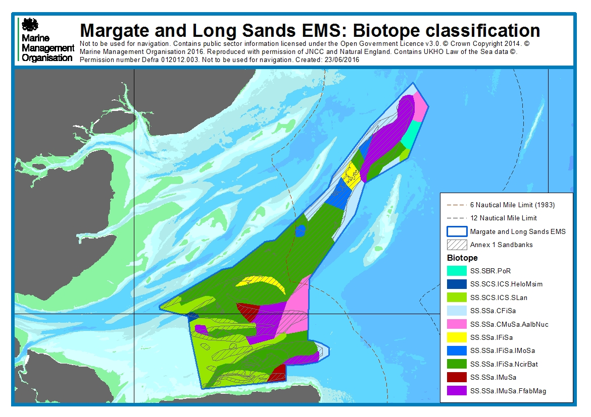

Annex 2a: UK VMS all gears ping data (including guardship) (0 to 6knots) broken down by years
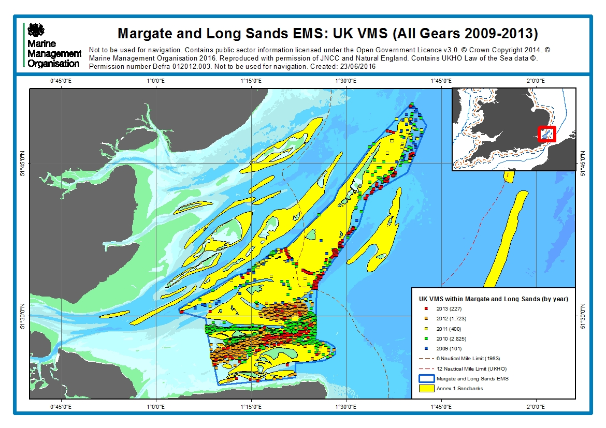
Annex 2b: UK VMS all gears ping data (excluding guardship) (0 to 6knots) broken down by years
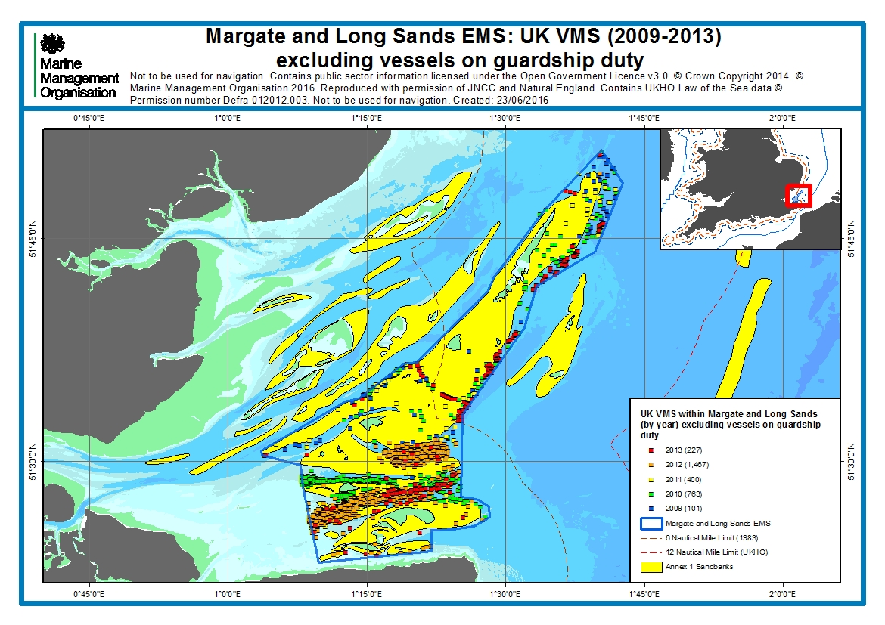
Annex 2c: Belgium VMS all gears ping data (0 to 6knots) broken down by years
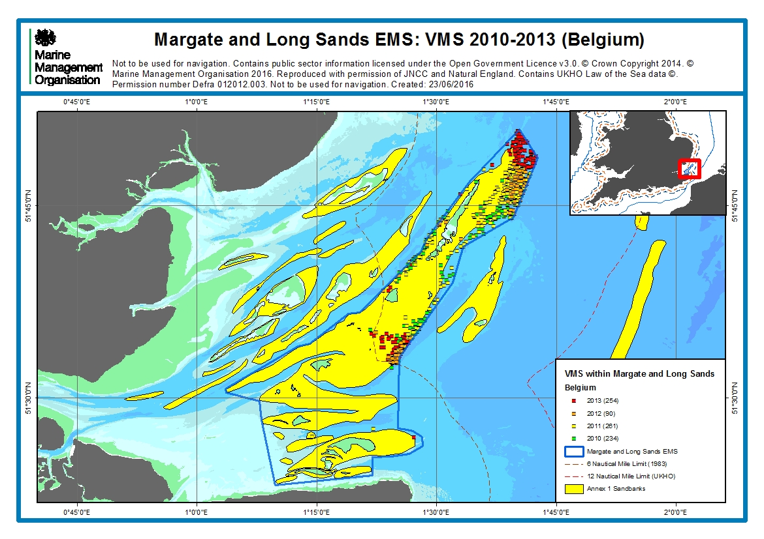
Annex 2d: French VMS all gears ping data (0 to 6knots) broken down by years
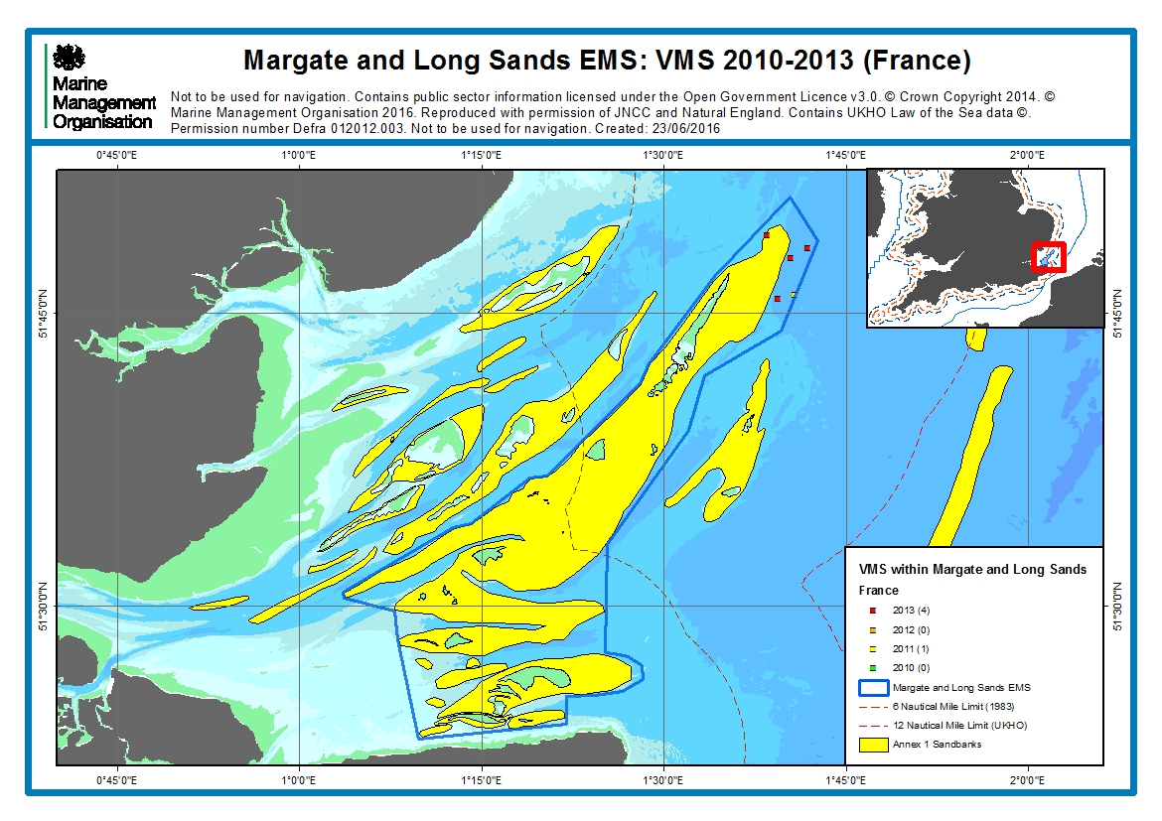
Annex 2e: 2010 UK VMS ping data (0 to 6knots) by gear
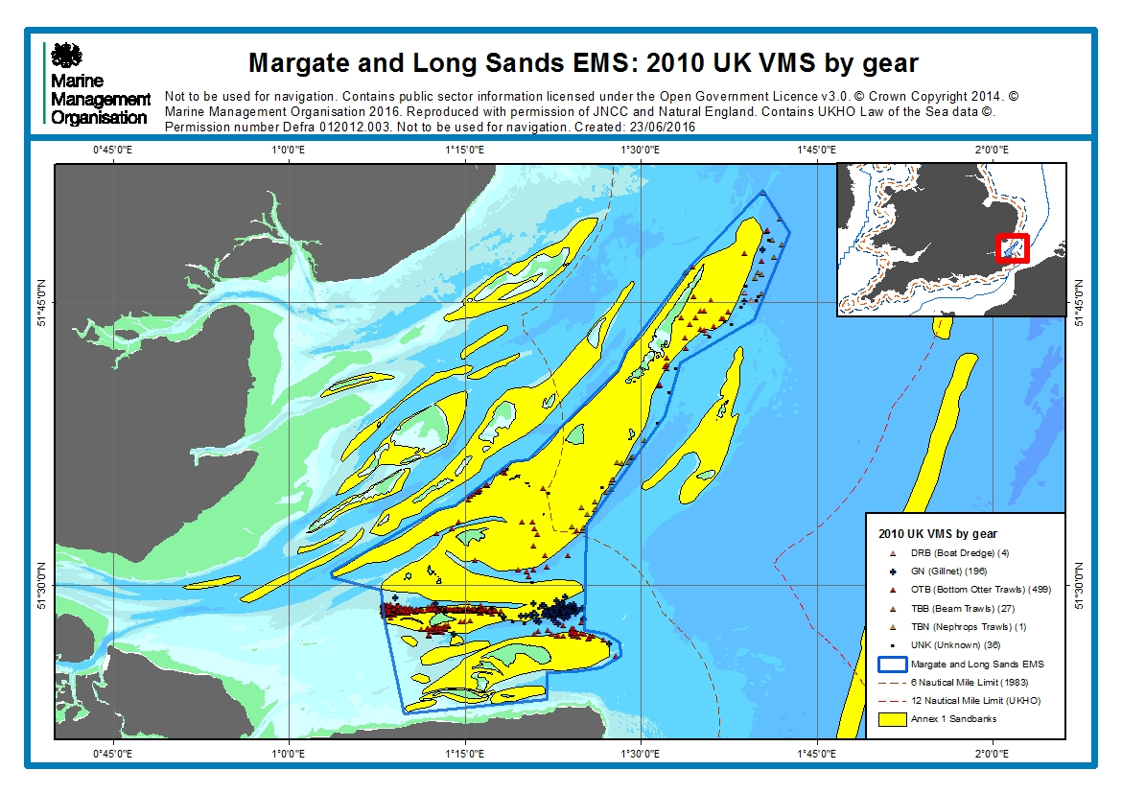
Annex 3a: Fishermap chart - Bottom gear
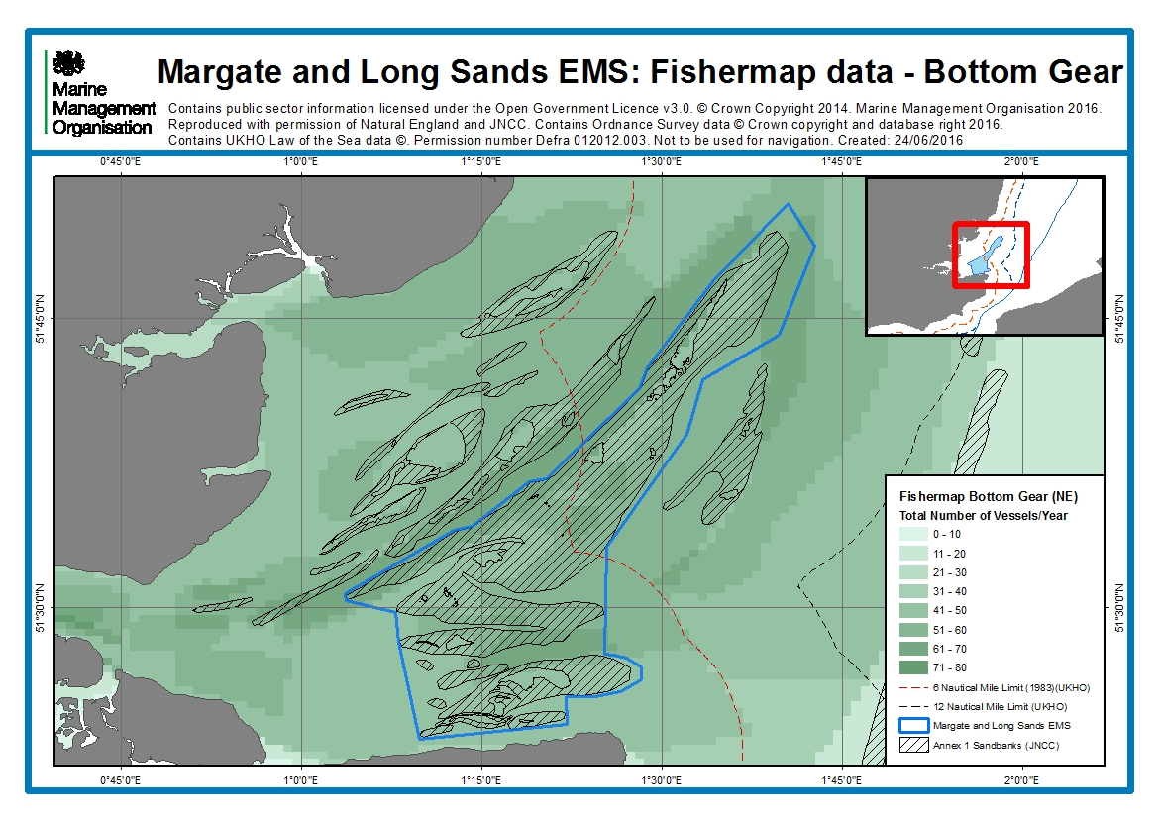
Annex 3b: Fishermap chart - Dredges
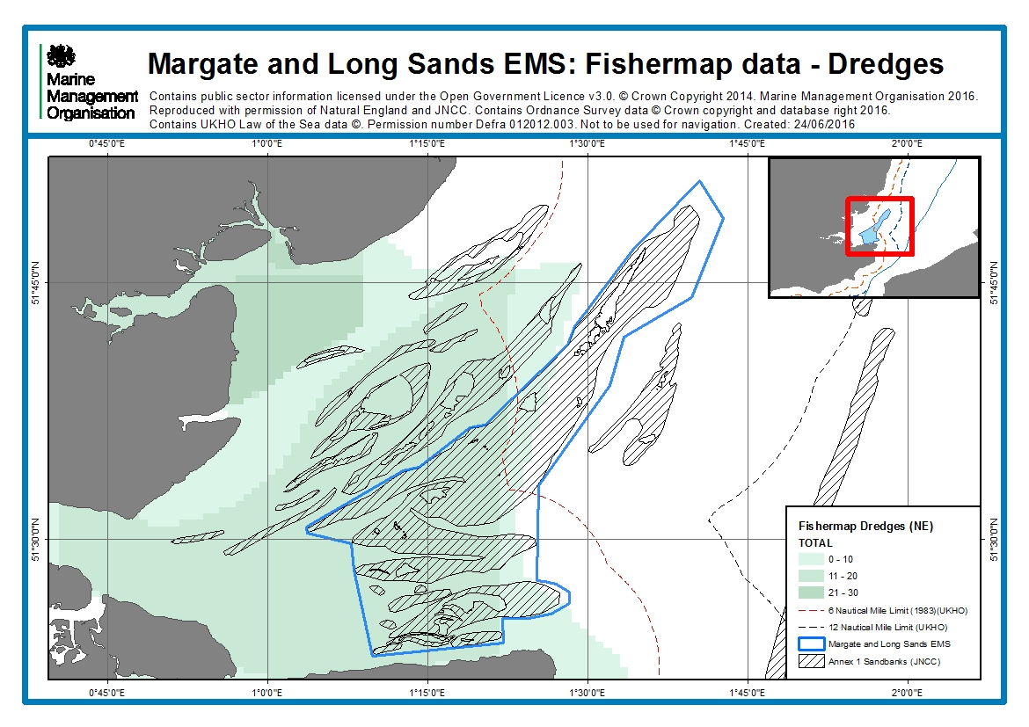
Annex 3c: Fishermap chart - Potting
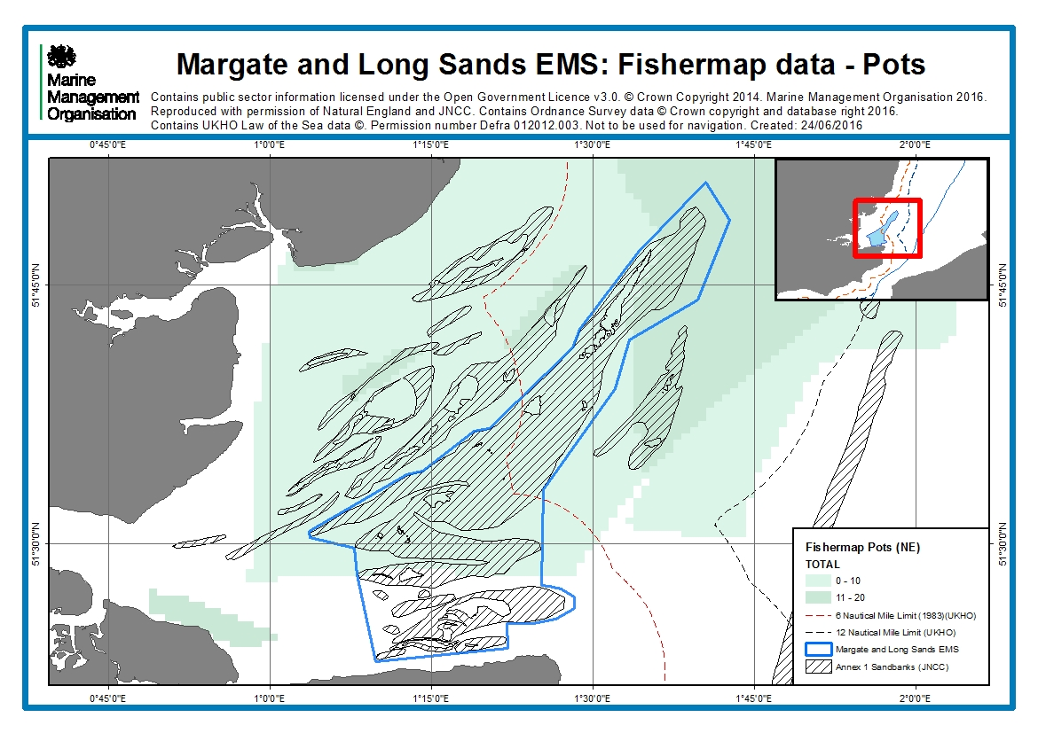
Annex 3d: Fishermap chart – Netting
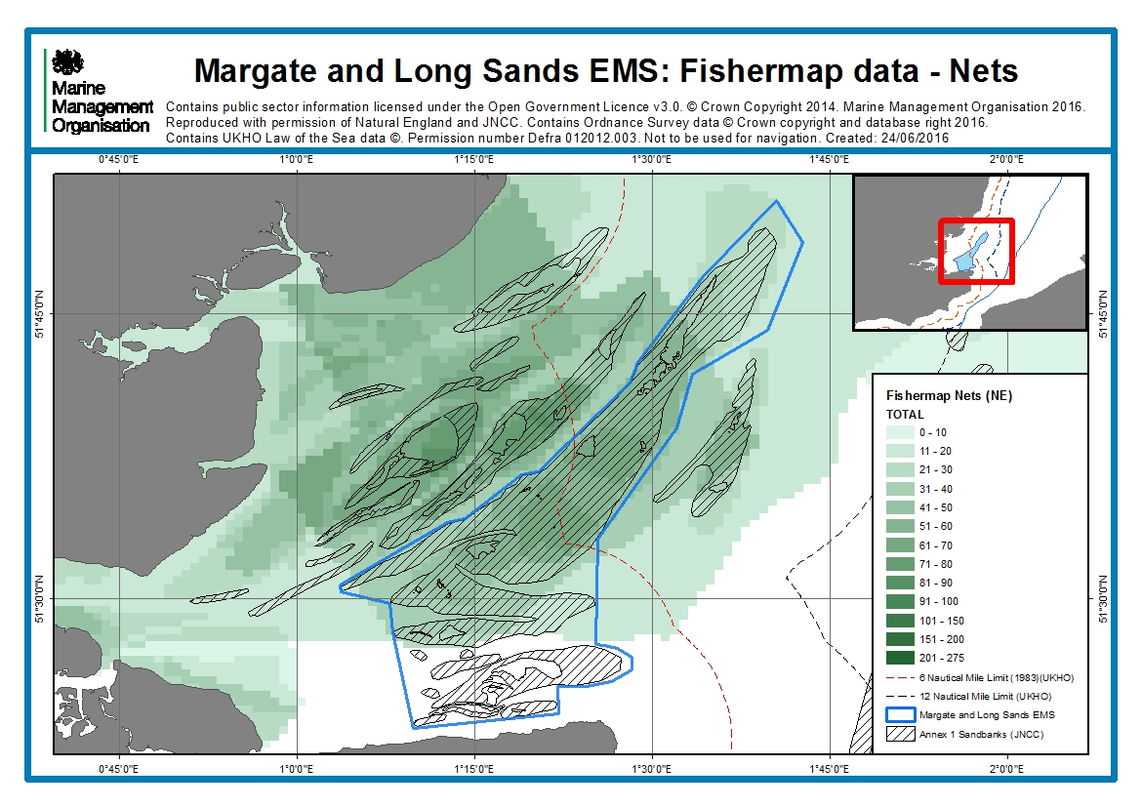
Annex 4a: Sighting data per unit effort for mobile gears within Margate and Long Sands EMS
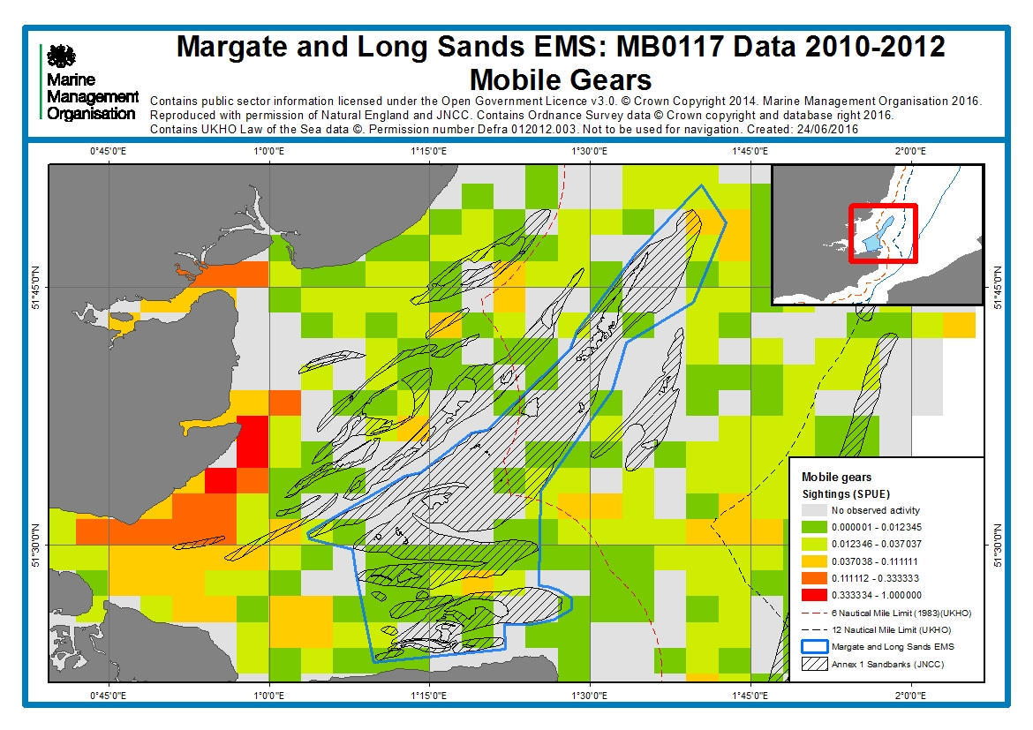
Annex 4b: Sighting data per unit effort for potting within Margate and Long Sands EMS
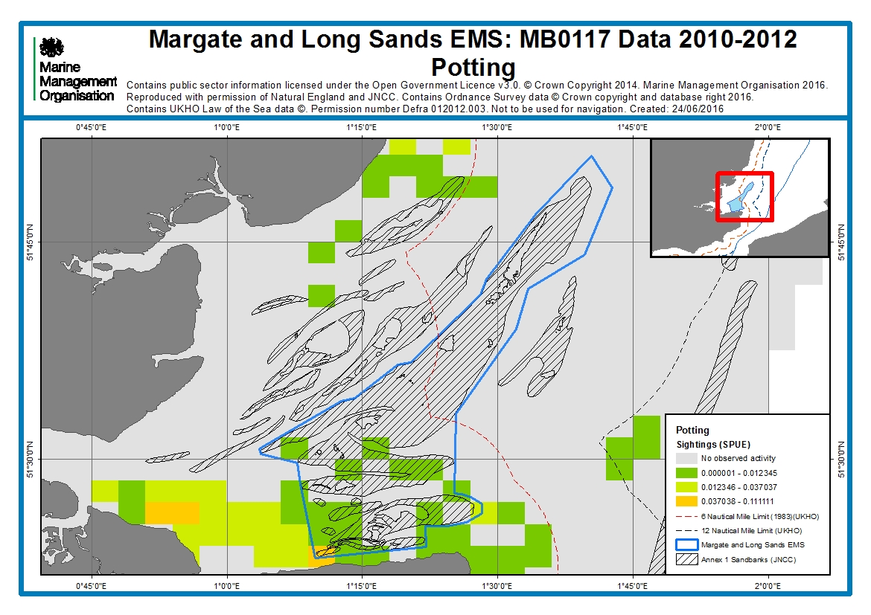
Annex 4c: Sighting data per unit effort for netting within Margate and Long Sands EMS
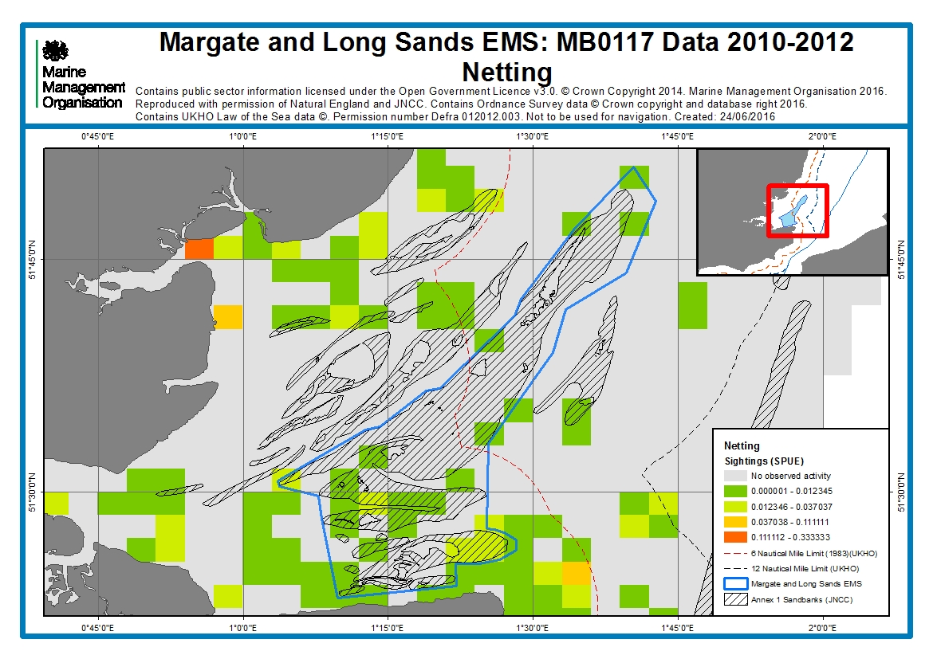
Annex 5a: Kent and Essex IFCA trawling sightings data (2010 – 30/07/2015)
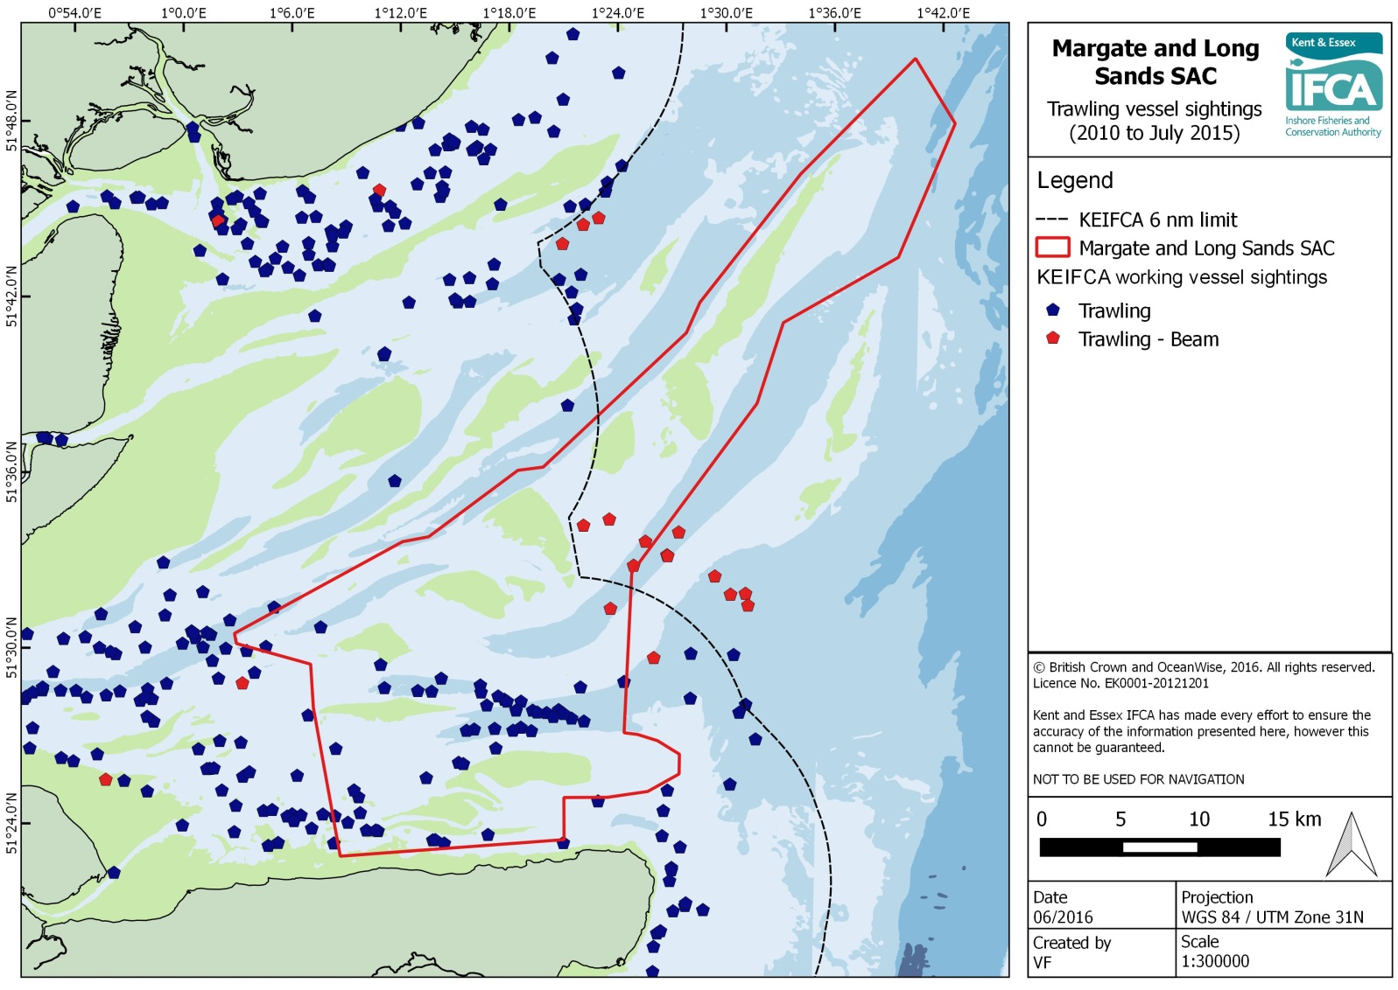
Annex 5b: Kent and Essex IFCA potting sightings data (2010 – 30/07/2015)
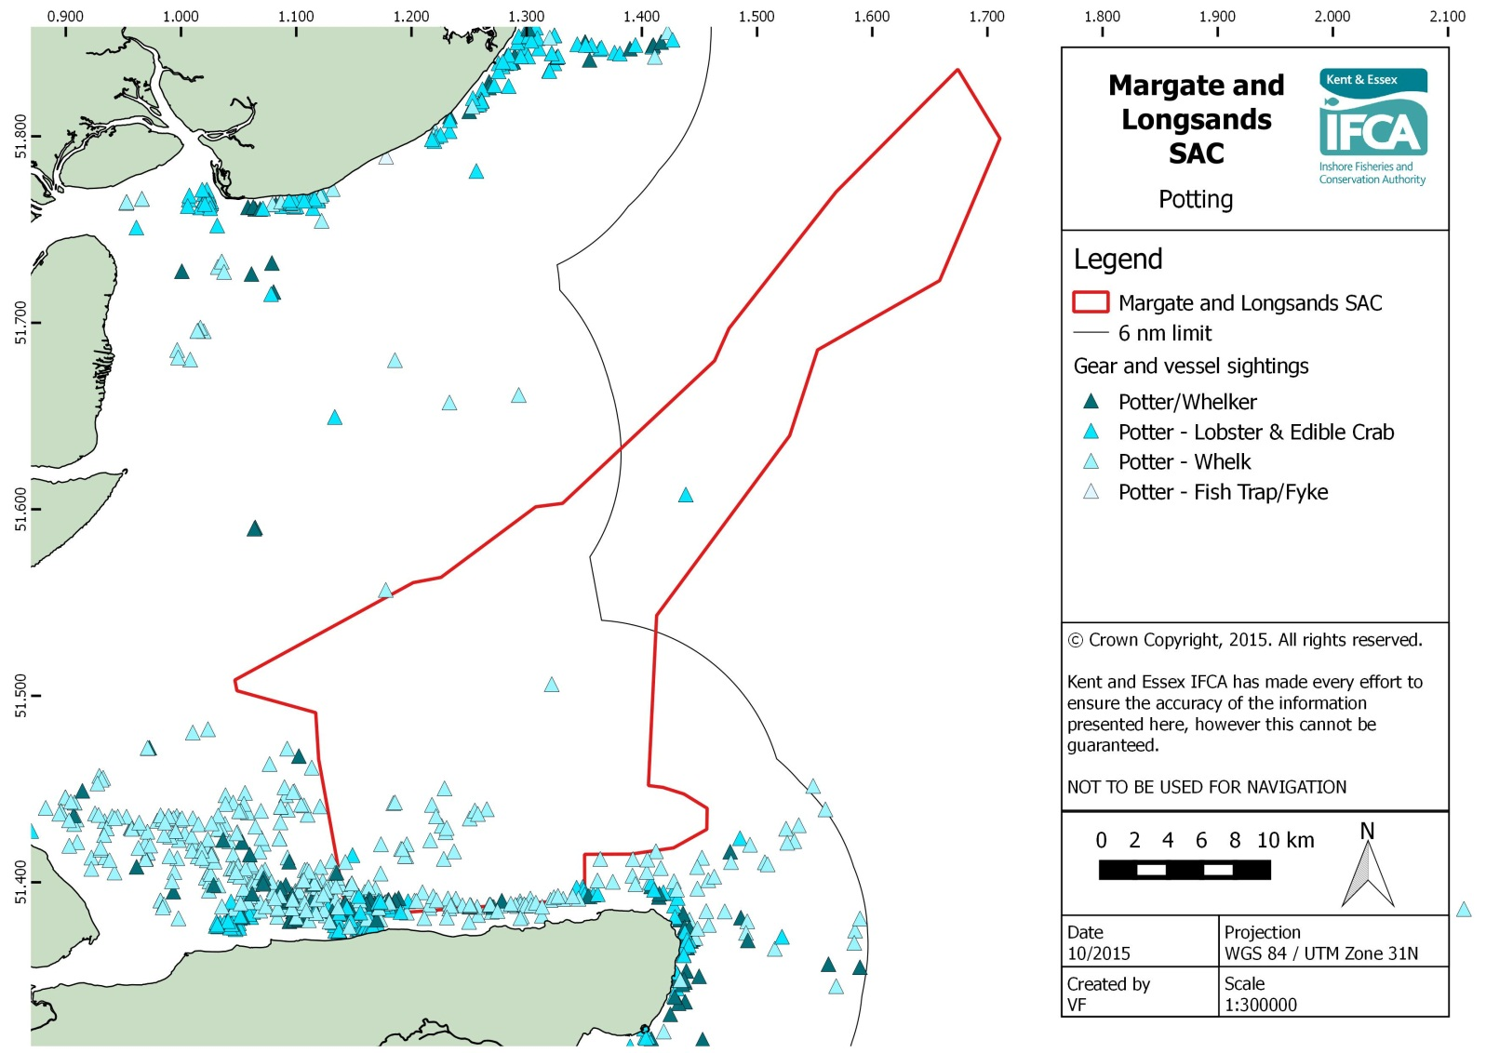
Annex 6: UK Landings Data for ICES rectangles 31F1 and 32F1
Values | Species Group | 2009 | 2010 | 2011 | 2012 | 2013 | Grand Total | Annual average (over 5 years) | VMS based estimate of annual activity in detailed site
Qty landed (tonnes) | Crustacean | 42 | 44 | 71 | 70 | 55 | 283 | 57 | 7.0
 | Demersal | 717 | 566 | 698 | 560 | 648 | 3,188 | 638 | 36.5
 | Mollusc | 196 | 322 | 507 | 849 | 2,496 | 4,369 | 874 | 11.5
 | Pelagic | 169 | 5 | 7 | 3 | 242 | 426 | 85 | 0.0
 | Total | 1,124 | 937 | 1,282 | 1,482 | 3,441 | 8,266 | 1,654 | 55.1
Value landed | Crustacean | £141,789 | £171,924 | £425,638 | £278,317 | £235,584 | £1,253,252 | £0.25mn | £0.10mn
 | Demersal | £2,042,791 | £1,588,954 | £2,102,063 | £1,285,074 | £1,161,874 | £8,180,756 | £1.64mn | £0.12mn
 | Mollusc | £158,440 | £229,375 | £380,832 | £633,070 | £1,593,312 | £2,995,028 | £0.60mn | £0.01mn
 | Pelagic | £48,863 | £4,288 | £5,688 | £3,082 | £68,187 | £130,108 | £0.03mn | £0.00mn
 | Total | £2,391,883 | £1,994,541 | £2,914,221 | £2,199,542 | £3,058,958 | £12,559,144 | £2.51mn | £0.23mn

Values | Gear group | 2009 | 2010 | 2011 | 2012 | 2013 | Grand Total | Average over 5 years  (tonnes/ £m pa) | VMS based estimate of annual activity in detailed site
Quantity landed (tonnes) | Gill nets and entangling nets | 533 | 438 | 496 | 383 | 376 | 2,224 | 445 | 0.0
 | Harvesting machines | 66 | 51 | 77 | 37 | 1,587 | 1,818 | 364 | 39.3
 | Hooks and lines | 2 | 2 | 1 | 3 | 1 | 9 | 2 | 0.0
 | Miscellaneous gear |  |  | 0 |  |  | 0 | 0 | 0.0
 | Seine nets | 15 | 10 | 4 | 12 | 30 | 70 | 14 | 0.0
 | Traps | 129 | 286 | 452 | 832 | 929 | 2,629 | 526 | 0.0
 | Trawls | 380 | 150 | 252 | 216 | 518 | 1,515 | 303 | 15.7
 | Total | 1,124 | 937 | 1,282 | 1,482 | 3,441 | 8,266 | 1653 | 55.1
Value landed | Gill nets and entangling nets | £1,462,170 | £1,219,357 | £1,328,188 | £838,104 | £688,022 | £5,535,842 | £1.11mn | £0.00mn
 | Harvesting machines | £75,972 | £63,340 | £130,124 | £82,656 | £947,904 | £1,299,996 | £0.26mn | £0.08mn
 | Hooks and lines | £3,415 | £6,422 | £4,531 | £20,444 | £11,849 | £46,662 | £0.01mn | £0.00mn
 | Miscellaneous gear |  |  | £466 |  |  | £466 | £0.00mn | £0.00mn
 | Seine nets | £66,198 | £35,499 | £7,111 | £40,261 | £59,384 | £208,452 | £0.04mn | £0.00mn
 | Traps | £148,578 | £278,776 | £639,862 | £753,457 | £807,916 | £2,628,588 | £0.53mn | £0.00mn
 | Trawls | £635,550 | £391,147 | £803,939 | £464,621 | £543,882 | £2,839,138 | £0.57mn | £0.15mn
 | Total | £2,391,883 | £1,994,541 | £2,914,221 | £2,199,542 | £3,058,958 | £12,559,144 | £2.51mn | £0.23mn

Annex 7: Margate and Long Sands EMS biotope sensitivity information

The sensitivity of the biotopes within the site varies depending on their location. Species present in more stable areas (troughs) will be more prone to disturbance and therefore more sensitive to fishing activity (figure 2).

The Bhatia 2015 study identified a diverse range and abundance of fauna with polychaetes, crustaceans and molluscs dominating the faunal assemblages. Distribution of taxa was attributed to habitat preference with more sensitive species (deposit feeders and burrowing species) such as Abra alba being present in more stable areas mainly within the troughs between sandbanks and the area in deeper waters on the Long Sands Head section and in areas identified within the 6nm limit.

Abundant presence of Lanice conchilega was found within the site which is an indicator of a mobile stable habitat which can further establish more biodiversity within the site. This is further supported by the presence of S. spinulosa in the Long Sands Head area within the subtidal mixed sediment area of the site (figure 1). Notable changes of biotope composition were evident from the previous study in 2006 that mud or mixed sediments have increased the diversity of the site with the potential for the development of S. spinulosa reef especially within the L. conchilega area within the Long Sands Head area. S. spinulosa is an important component of the overall community of species and can contribute to increased species diversity and abundance by attracting other species into the area.

L. conchilega within the 6nm limit are correlated with the hydrodynamic system within the tide swept infralittoral sand and is therefore more naturally adapted to physical disturbance. This is also the case for biotopes present in the subfeature subtidal sands and coarse sediments within the site (annex 1).

Recoverability of all biotopes are generally high due to high spat release but recruitment success very much depends on larval and post settlement mortality. Spawning stages varies depending on the biotope but generally falls between August (highest) and February (lowest). Fabulina fabula is generally long lived and has a low turnover. Physical disturbance may exacerbate mortality of new recruits through starvation. Recoverability of biotopes especially Magelona mirabilis is more successful in areas with an already established mature colony therefore ongoing disturbance from fishing activities may perturb the development of mature species.

Bivalve molluscs such as Abra alba and Mucula nitidosa inhabit more stable sediments in low energy environments. These deposit feeders can also recover quickly but larval and post settlement mortality can vary from 30 – 90%, therefore recruitment is infrequent. Summer recruits are more successful than autumn recruits as maturity will be delayed until the following year which minimises recruitment success. Biotopes associated with more mobile areas are species poor and naturally adapted to disturbance.

Table 28 gives further information on the specific biotopes present.
Figure 2: Sensitive biotope sampling points
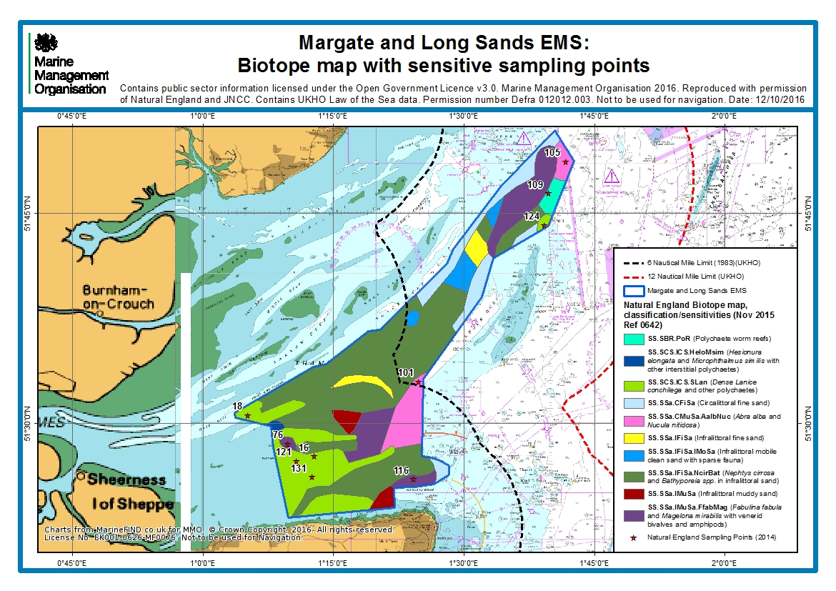

Table 28: Margate and Long Sands EMS biotope

BIOTOPE | BIOTOPE DESCRIPTION
SS.SBR.PoR  Polychaete worm reefs Sabellaria spinulosa and Polydora spp on stable circalittoral mixed sediment | Sublittoral reefs of polychaete worms in mixed sediments found in a variety of hydrographic conditions. Such habitats may range from extensive structures of considerable size to loose agglomerations of tubes. Such communities often play an important role in the structural composition or stability of the seabed and provide a wide range of niches for other species to inhabit. Consequently polychaete worm reefs often support a diverse flora and fauna.
SS.SCS.ICS.HeloMsim  Hesionura elongata and Microphthalmus similis with other interstitial polychaetes in infralittoral mobile coarse sand | On infralittoral sandbanks and sandwaves and other areas of mobile medium-coarse sand, populations of interstitial polychaetes may be found. These habitats consist of loosely packed grains of sand forming waves up to several metres high often with gravel, or occasionally silt, in the troughs of the waves.  These habitats support interstitial communities living in the spaces between the grains of sand, in particular hesionurid polychaetes.
SS.SCS.ICS.SLan  Dense Lanice conchilega and other polychaetes in tide swept infralittoral sand | Dense beds of Lanice conchilega occur in coarse to medium fine gravelly sand in the shallow sublittoral, where there are strong tidal streams or wave action.
SS.SSa.CFiSa  Circalittoral fine sand | Clean fine sands with less than 5% silt/clay in deeper water, either on the open coast or in tide-swept channels of marine inlets in depths of over 15-20m. The habitat may also extend offshore and is characterised by a wide range of echinoderms (in some areas including the pea urchin Echinocyamus pusillus), polychaetes and bivalves. This habitat is generally more stable than shallower, infralittoral sands and consequently supports a more diverse community.
SS.SSa.CMuSa.AalbNuc  Abra alba, Nucula nitida and Corbula gibba in circalittoral muddy sand or slightly mixed sediment | Non-cohesive muddy sands or slightly shelly/gravelly muddy sand characterised by the bivalves Abra alba and Nucula nitidosa. Other important taxa include Nephtys spp., Chaetozone setosa and Spiophanes bombyx with Fabulina fabula also common in many areas. The echinoderms Ophiura albida and Asterias rubens may also be present.
SS.SSa.IFiSa  Infralittoral fine sand | Clean sands which occur in shallow water, either on the open coast or in tide-swept channels of marine inlets. The habitat typically lacks a significant seaweed component and is characterised by robust fauna, particularly amphipods (Bathyporeia) and robust polychaetes including Nephtys cirrosa and Lanice conchilega.
SS.SSa. IFiSa.IMoSa  Infralittoral mobile clean sand with sparse fauna | Medium to fine sandy sediment in shallow water, often formed into dunes, on exposed or tide-swept coasts often contains very little infauna due to the mobility of the substratum.
SS.SSaIFiSa.NcirBat  Nephtys cirrosa and Bathyporeia spp. in infralittoral sand | Well-sorted medium and fine sands characterised by Nephtys cirrosa and Bathyporeia spp. (and sometimes Pontocrates spp.) which occur in the shallow sublittoral to at least 30 m depth. This biotope occurs in sediments subject to physical disturbance, as a result of wave action (and occasionally strong tidal streams).
SS.ssa.IMuSa  Infralittoral muddy sand | Non-cohesive muddy sand (with 5% to 20% silt/clay) in the infralittoral zone, extending from the extreme lower shore down to more stable circalittoral zone at about 15-20 m. The habitat supports a variety of animal-dominated communities, particularly polychaetes (Magelona mirabilis, Spiophanes bombyx and Chaetozone setosa), bivalves (Fabulina fibula and Chamelea gallina) and the urchin Echinocardium cordatum.
SS.IGS.FaS.FabMag  Fabulina fabula and Magelona mirabilis with venerid bivalves in infralittoral compacted fine sand | This biotope is characterised by burrowing bivalves and worms. It may be sensitive to dredging when it is occurring on the more stable gravelly and muddy sand communities which will be more associated with the troughs.  These biotopes are associated with areas of weak tidal streams.

Annex 8: Monitoring and Control Process

Annex 9: Assumptions used to calculate spatial footprint (p) values

Pots

- Size of pot: based on GAEL Force Lobster/Crab creel (609.6mm x 406.4mm)
- Number of vessels and days spent fishing: derived from VMS/landings records.
- Number of pots used by vessels: derived from local fisherman.

Nets (gill nets/trammel nets)

- Gear information: taken from report on a workshop on the physical effects of fishing activities on the Dogger Bank
- Number of vessels and days at sea: derived from VMS/landings records.
- Number of nets hauled: supplied by IFCA.

Reference list

Bhatia, N., 2015. Grab Sampling of Margate and Long Sands SAC. IECS Report No. ZBB828 D1-2015. A report to Natural England.

Blasdale, T., Duffy, M., Enever, R., Fisher, R., Lannin, F.A., Marubini, F., Stevens and Tasker, M., 2011. Advice from the Joint Nature Conservation Committee and Natural England with regard to fisheries impacts on Marine Conservation Zones.

BMT Environmental Management Consultants, Cordah/DTI.009.04.01.06/2003, Offshore Wind Energy Generation: Phase 1 Proposals and Environmental Report [Online]. Available: https://www.gov.uk/government/uploads/system/uploads/attachment_data/file/194363/offshore_wind_SEA_final.pdf [Accessed June 2016].

S.G. Bolam, R.C.Coggan, J.Eggleton, M.Diesing, D.Stephens Journal of Sea Research 85, 2014 162–177 “Sensitivity of macrobenthic secondary production to trawling in the English sector of the Greater North Sea: A biological trait approach”.

Coleman, R.A., Hoskin.M.G., von Carlshausen. E., Davis, C.M., 2013 Using a no-take zone to assess the impacts of fishing: Sessile epifauna appear insensitive to environmental disturbances from commercial potting. Journal of Experimental Marine Biology and Ecology, 440, 100-107.

Collie, J.S., Hall, S.J., Kaiser, M.J. And Poiner, I.R., 2000. A quantitative analysis of fishing impacts on shelf-sea benthos. Journal of animal ecology. Vol. 69, 785-798.

Defra project MB0117: Understanding the distribution and trends in inshore fishing activities and the link to coastal communities, 2014. Available: http://randd.defra.gov.uk/Default.aspx?Menu=Menu&Module=More&Location=None&Completed=1&ProjectID=18126 [Accessed June 2016]

Dernie, K.M., Kaiser, M.J, & Warwick, R.M., 2003. Recovery rates of benthic communities following physical disturbance. Journal of Animal Ecology, 72, 1043 – 1056.

Eno, N.C., Frid, D.L.J., Hall, K., Ramsay, K., Sharp, R.A.M., Brazier, D.P., Hearn, S., Dernie, K.M., Robinson, K.A., Paramore, O.A.L., Robinson, L.A., 2013. Assessing the sensitivity of habitats to fishing: from seabed maps to sensitivity maps. Journal of Fish Biology, doi:10.1111/jfb.12132, available online at wileyonlinelibrary.com.

EMU LTD., 2006. Benthic Survey of the Outer Thames Estuary Sandbank System. Final Report. Report 06/J/1/03/0837/0572 for English Nature.

Foden, J., Rogers, S.I., Jones, A.P., 2010. Recovery of UK seabed habitats from benthic fishing and aggregate extraction – towards a cumulative impact assessment. Marine Ecology Progress series, Vol. 411: 259–270, doi: 10.3354/meps08662.

Grieve, C., Brady, D., & Hans Polet, IR., 2011. Best Practices for Managing, Measuring and Mitigating the Benthic Impacts of Fishing. Final Report to the Marine Stewardship Council.

Grieve, C., Brady, D.C., Polet, H., 2014. Review of habitat dependent impacts of mobile and static fishing gears that interact with the sea bed – Part 1. Marine Stewardship Council Science, 2 18–88.

Hall, K., Paramor, O.A.L., Robinson, L.A., Winrow-Giffin, A., Frid, C.L.J., Eno, N.C., Dernie, K.M., Sharp, R.A.M., Wyn, G.C & Ramsay, G.C., 2008. Mapping the sensitivity of benthic habitats to fishing in Welsh waters – development of a protocol; CCW (Policy Research) Report No: 8/12. 85pp.

Hiddink, J.G., Jennings, S., Kaiser, M.J., Queiros, A.M., Duplisea, D.E, and Piet G.J., 2006. Cumulative impacts of seabed trawl disturbance on benthic biomass, production, and species richness in different habitats. Canadian Journal of Fisheries and Aquatic Science 63: 721 – 736.

Jennings, S.J., Pinnegar, J.K., Polunin, N.V.C., Warr, K.J., 2001. Impacts of trawling disturbance on the trophic structure of benthic invertebrate communities. Marine Ecology Progress Series Vol. 213: 127–142.

Joint Nature Conservation Committee (JNCC), 2014a: MCZ Features: Subtidal Coarse Sediment [Online]. Joint Nature Conservation Committee (JNCC). Available: http://jncc.defra.gov.uk/page-5801 [Accessed June-16]

Kaiser, M.J., Clarke, K.R., Hinz, H., Austen, M.C.V., Somerfield, P.K., Karakassis, I., 2006. Global analysis of response and recovery of benthic biota to fishing. Marine Ecology Progress Series, 311, 1-14.

Kaiser, M.J., Collie, J.S.,Hall, S.J., Jennings, S. And Roiner., 2002 Modification of marine habitats by trawling activities: prognosis and solutions. Fish and fisheries. Vol. 3, 114-136.

Kaiser, M. J., Edwards, D. B., Armstrong, P. J., Radford, K., Lough, N. E. L., Flatt, R. P. and Jones, H. D., 1998. Changes in megafaunal benthic communities in different habitats after trawling disturbance. ICES Journal of Marine Science: Journal du Conseil. Vol. 55 (3), 353-361.

Lambert I. Glawys, Simon Jennings, Michel J. Kaiser, Thomas W. Davies and Jan G. Hiddink Journal of Applied Ecology, 2014. doi: 10.1111/1365-2664.12277 “Quantifying recovery rates and resilience of seabed habitats impacted by bottom fishing”.

Magda, J.N., Bergman, N., van Santbrink, J.W., 2000. Mortality in megafaunal benthic populations caused by trawl fisheries on the Dutch continental shelf in the North Sea in 1994. ICES Journal of Marine Science. 57: 1321 – 1331.

Jacobo Martín, Pere Puig, Albert Palanques, Marta Ribó., 2014. Trawling-induced daily sediment resuspension in the flank of a Mediterranean submarine canyon. Deep Sea Research Part II: Topical Studies in Oceanography, Volume 104,Pages 174-183

National Federation of Fishermen’s Organisations (NFFO) project: Supporting risk-based fisheries assessments for MPAs - Assessment of Otter Trawling Activity in Margate and Long Sands Site of Community Importance (SCI) (2015). Available: http://www.abpmer.co.uk/experience/fisheries-and-aquaculture-experience/assessing-fisheries-mpas/ [Accessed June 2016]

Natural England, 2016: draft supplementary advice on conserving and restoring site features [Online]: Available: https://www.gov.uk/government/uploads/system/uploads/attachment_data/file/495246/margate-long-sands-sci-supplementary-advice.pdf [Accessed June 2016]

Natural England, 2012: Margate and Long Sands cSAC (UK0030371) Regulation 35(3) of The Conservation of Habitats and Species Regulations 2010 [Online]: Available: http://publications.naturalengland.org.uk/publication/3251957 [Accessed June 2016]

F.G. O’Neill, K. Summerbell., 2011. The mobilisation of sediment by demersal otter trawlsOriginal Research Article. Marine Pollution Bulletin, Volume 62, Issue 5, May 2011, Pages 1088-1097.
Queiros, A.M, Hiddink, J.G., Kaiser, M.J., Hinz, H. Journal of Experimental Marine Biology and Ecology 335, 2006 91–103. Effects of chronic bottom trawling disturbance on benthic biomass, production and size spectra in different habitats.

Roberts, C., Smith, C., Tillin, H. Tyler-Walters, H., 2010. Review of existing approaches to evaluate marine habitat vulnerability to commercial fishing activities.

RPS GROUP PLC., 2005. Environmental Statement. Volume 1: Offshore Works. London Array Ltd.

Seafish, 2015: Multi Rig Trawl - nephrops triple rig [Online]: Available http://www.seafish.org/geardb/gear/multi-rig-trawl-nephropsgroundfish-triple-rig/ [Accessed June 2016]

Tilin, H.M., Hull, S.C., Tyler-Walters, H., 2010. Development of a sensitivity Matrix (pressures-MCZ/MPA features). Report to the Department of Environment, Food and Rural Affairs from ABPMer, Southampton and the Marine Life Information Network (MarLIN) Plymouth: Marine Biological Association of the UK. Defra Contract No. MB12 Task 3A, Report No. 22.

Todd, D., Baseline survey of Margate and Long Sands cSAC – Information note (2015).

van Marlen, B., Wiegerinck, J.A.M., van Os-Koomen, E., van Barneveld, E., 2013. Catch comparison of flatfish pulse trawls and a tickler chain beam trawl. Fisheries Research 151 57– 69.

Walmsley, S.F., Bowles, A., Eno, N.C. & West, N., 2015.Evidence for Management of Potting Impacts on Designated Features.

Margate and Long Sands Site of Community Importance (SCI). SCIs are sites that have been adopted by the European Commission but not yet formally designated by the government of each country. The umbrella term European marine site is used in this document to avoid confusion.
JNCC site details: http://jncc.defra.gov.uk/protectedsites/sacselection/sac.asp?EUCode=UK0030371
www.gov.uk/government/publications/fisheries-in-european-marine-sites-matrix
http://eur-lex.europa.eu/legal-content/EN/TXT/PDF/?uri=CELEX:31992L0043&from=EN
The test for likely significant effect under article 6(3) of the Habitats Directive is not required for activities which are directly connected to or necessary to the management of the site. Fishing activities are considered to be not directly connected to or necessary to the management of the site unless otherwise indicated.
Bait dragging does not take place in the UK outside of Poole Harbour
www.gov.uk/government/uploads/system/uploads/attachment_data/file/441098/MGN_501_Combined.pdf
Kent and Essex IFCA byelaws: http://www.kentandessex-ifca.gov.uk/i-want-to-find-out-about/regulations/keifca-byelaws/
www.gov.uk/government/uploads/system/uploads/attachment_data/file/459118/23con.pdf
Kent and Essex IFCA Comms
http://www.kentandessex-ifca.gov.uk/i-want-to-find-out-about/regulations/keifca-byelaws/byelaws-a/
Harvesting machines have only recently been recorded by MMO from 2013 hence the large increase in landing statistics
The number of visits is based on worst case scenario.
http://www.kentandessex-ifca.gov.uk/i-want-to-find-out-about/regulations/keifca-byelaws/byelaws-a/
Kent and Essex IFCA officer
Kent and Essex IFCA officer
MMO coastal officer
http://www.kentandessex-ifca.gov.uk/i-want-to-find-out-about/regulations/keifca-byelaws/keifca-district-byelaws/
Kent and Essex IFCA officer
MMO coastal officer
Kent and Essex IFCA officer
MARG Ltd in association with Envision Mapping Ltd, 2015
http://jncc.defra.gov.uk/pdf/IDRBNR_Reg%2035_Conservation%20Advice_v4.0.pdf
http://jncc.defra.gov.uk/pdf/IDRBNR_Reg%2035_Conservation%20Advice_v4.0.pdf
http://www.kentandessex-ifca.gov.uk/i-want-to-find-out-about/regulations/keifca-byelaws/
http://www.kentandessex-ifca.gov.uk/i-want-to-find-out-about/regulations/keifca-byelaws/
Determination based on level of risk on sensitive parts of the sandbank feature
http://jncc.defra.gov.uk/pdf/IDRBNR_Reg%2035_Conservation%20Advice_v4.0.pdf
http://publications.naturalengland.org.uk/publication/3251957
http://www.kentandessex-ifca.gov.uk/i-want-to-find-out-about/regulations/keifca-byelaws/
www.gov.uk/government/uploads/system/uploads/attachment_data/file/441098/MGN_501_Combined.pdf
Pulse fishing is covered under the same gear code at bottom towed gear.
JNCC http://www.jncc.gov.uk/marine/biotopes/

