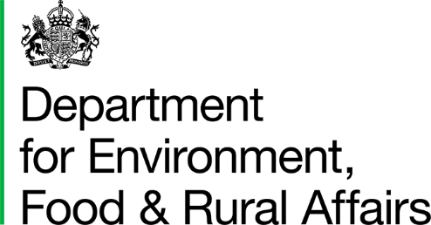 |  |  | T: 03459 335577  helpline@defra.gov.uk  www.gov.uk/defra
2 Marsham Street
London
SW1P 2BQ

 | Dear Consultee, |  | Date: 20/06/2025

Consultation on marine licences: changes to fees, exemptions and self-service licences
- I am writing to invite views on proposed amendments to marine licensing fees, exemptions and self-service licences.

- We are seeking views on proposed changes to:

- increase fees for the marine licence service provided by the Marine Management Organisation (MMO)

- change the list of activities that need a marine licence – to add 5 new exemptions, amend 4 exemptions and remove some existing exemptions

- add 2 new self-service licences

- The aim of these changes is to make the marine licensing service more efficient, whilst supporting the government’s plans for growth and nature recovery.

- The consultation applies to the English inshore and offshore region and the Northern Ireland offshore region regulated by the MMO.

- The following documents may be found on GOV.UK.

- consultation on marine licensing efficiencies

- consultation letter

- privacy notice

- We welcome your views and comments on the proposals.

Responses
- To submit your consultation response please complete the consultation questionnaire provided through Citizen Space (Citizen Space is an online consultation tool).

- If you require a copy of the consultation, please contact us at marine.licensing@defra.gov.uk

- Responses should be received by 15th August 2025

Using and sharing your information
- How we use your personal data is set out in the consultation and call for evidence exercise privacy notice which can be found here https://www.gov.uk/government/publications/defras-consultations-and-call-for-evidence-exercises-privacy-notice

- If you have any comments or complaints about the consultation process, please email: consultation.coordinator@defra.gov.uk

- Thank you for your help in this matter. If you have any queries, please contact us as above.

Yours Faithfully,

Marine Licensing Team
marine.licensing@defra.gov.uk
Department for Environment, Food and Rural Affairs

