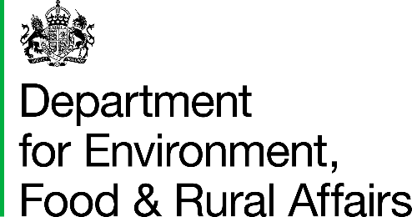 |  |  | T: 03459 335577  helpline@defra.gov.uk  www.gov.uk/defra
 |  | Mandatory Animal Health and Welfare Pathway Team  Department for Environment, Food and Rural Affairs  Seacole Building 2nd Floor  2 Marsham Street  London  SW1P 4DF | T: 03459 335577  helpline@defra.gov.uk  www.gov.uk/defra
 |  |  | 24th February 2026

Consultation on proposed legislation to mandate the requirement for an annual Animal Health and Welfare Review and endemic disease eradication programmes
Dear Consultee,
We are inviting views on proposed new requirements for livestock keepers of cattle, sheep and pigs in England. These proposals are designed to introduce a new phase in the Animal Health and Welfare Pathway, facilitating collaboration between farmers and vets to enhance livestock health, welfare and biosecurity. This new phase builds on the current voluntary and funded phase of the Animal Health and Welfare Review, to secure the lasting benefits of the review.
The legislation would require farmers of cattle, sheep and pigs to have an annual Animal Health and Welfare Review with their vet to review the health and welfare of their animals and discuss overall farm biosecurity and responsible use of medicines. Sheep farmers would be required to produce a mandatory flock health plan, developed by farmers alongside their vet.
We also propose the introduction of mandatory disease eradication programmes for Bovine Viral Diarrhoea (BVD) in cattle and Porcine Reproductive and Respiratory Syndrome (PRRS) in pigs. These production-limiting diseases have high impacts on the sectors, with BVD estimated to cost the cattle sector £14 million to £36 million each year, while PRRS costs the pig sector an estimated £52 million each year. The introduction of mandatory control and eradication programmes would ensure that all farms are working together to reduce the spread and impact of these diseases, resulting in enhanced health and welfare and improved productivity.
The consultation will be open for 12 weeks. We welcome your views and comments on the proposals.
The following documents may be found on Citizen Space:
- Consultation document
- Annex A to consultation document
- Privacy notice
Responses
To submit your consultation response please complete the consultation questionnaire provided through Citizen Space (Citizen Space is an online consultation tool): https://consult.defra.gov.uk/legislative-solutions-universal-participation-for-the-animal-health-and-welfare-review-and-mandatory-eradication-schemes/animal-health-and-welfare-pathway-mandatory-propos/
If you are unable to use Citizen Space, you can download the consultation documents and return your response via email to AHWP-Mandatory@defra.gov.uk or via post to Mandatory Animal Health and Welfare Pathway Team, Department for Environment, Food and Rural Affairs, Seacole Building 2nd Floor, 2 Marsham Street, London, SW1P 4DF.
Responses should be received by 18th May 2026.
If you have any queries, please contact us as above.

Yours sincerely,

The Mandatory Animal Health and Welfare Pathway Team

Department for Environment, Food and Rural Affairs

Animal Health and Welfare Pathway - GOV.UK

