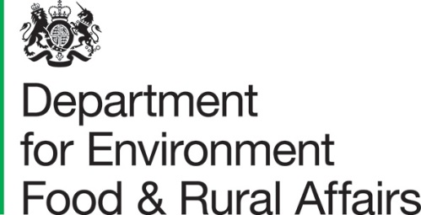 |  | ASF Consultation  Exotic and Endemic Disease Control  Department for Environment, Food and Rural Affairs  Seacole Building  2 Marsham Street  London  SW1P 4DF  Exotic.disease.policy@defra.gov.uk | T: 03459 335577  helpline@defra.gov.uk  www.gov.uk/defra
 | February 2022

Consultation on Amendments to African Swine Fever (ASF) Control Measures in England
Dear Consultee
I am writing to invite views on Defra’s proposals for amending the disease control measures for African Swine Fever (ASF) in England.
This informal consultation is directed at stakeholders in the pig industry and associated processors across Great Britain that will be affected by changes to requirements in relation to animal disease control. The consultation is also aimed at bodies that may work with the government or industry as part of animal disease control.
The proposed new measures introduced through this legislative change focus on ASF regionalisation and additional disease control measures that will assist in reducing the spread of ASF virus further, enabling trade to resume or continue with trading partners. The proposed additional measures will align England to current EU control measures for ASF.
The following documents may be found on GOV.UK: https://consult.defra.gov.uk/asf/ed5fd0b7
- Consultation letter
- Consultation document
- Privacy notice

Responses
To submit your consultation response please complete the consultation questionnaire
provided through Citizen Space using the link provided (Citizen Space is an online consultation tool).
If you require a copy of the consultation, please contact us at exotic.disease.policy@defra.gov.uk. Responses or additional information or documents can be sent to:
Consultation on Amendments to African Swine Fever (ASF) control measures in England Consultation Coordinator
Second floor
Foss House
Kings Pool
1 to 2 Peasholme Green
York
YO1 7PX
Responses should be received by 28th March 2022.

Consultation criteria
This consultation will last for 4 weeks. This is an informal consultation directed at stakeholders in the pig industry across Great Britain that will be affected by changes to requirements in relation to animal disease control in England. The consultation is also aimed at bodies that may work with the government or industry as part of animal disease control.
We appreciate the cross-cutting nature of this matter and are aware that the Devolved Administrations are also considering developing policy in this area. We therefore intend to share responses gathered with the Devolved Administrations.

Confidentiality and data protection
Please find the Consultations Privacy Notice uploaded alongside this consultation.
This consultation document and consultation process have been planned to adhere to the
Consultation Principles issued by the Cabinet Office.

Representative groups are asked to give a summary of the people and organisations they
represent and where relevant who else they have consulted in reaching their conclusions
when they respond.

Information provided in response to this consultation, including personal data, may be
published or disclosed in accordance with the access to information regimes these are
primarily the Environmental Information Regulations 2004 (EIRs), the Freedom of
Information Act 2000 (FOIA) and the Data Protection Act 2018 (DPA).

We have obligations, mainly under the EIRs, FOIA and DPA, to disclose information to
particular recipients or to the public in certain circumstances. If you want the information that you provide to be treated as confidential, please be aware that, as a public authority, the Department is bound by the Freedom of Information Act and may therefore be obliged to disclose all or some of the information you provide. In view of this it would be helpful if you could explain to us why you regard the information you have provided as confidential. If we receive a request for disclosure of the information we will take full account of your explanation, but we cannot give an assurance that confidentiality can be maintained in all circumstances. An automatic confidentiality disclaimer generated by your IT system will not, of itself, be regarded as binding on the Department.

If you have any comments or complaints about the consultation process, please
address them to the below address, or email consultation.coordinator@defra.gov.uk:

Consultation Coordinator
2nd floor
Foss House
Kings Pool
1-2 Peasholme Green
York
YO1 7PX

Thank you for your help in this matter. If you have any queries, please contact us.

Yours Faithfully
Exotic and Endemic Disease Control
Department for Environment, Food and Rural Affairs

